Annual Report

Summary

**2018**

|  |  |
| --- | --- |
| CONTENTS |  |
| ADDRESS BY THE DIRECTOR GENERAL OF THE NATIONAL CENTER FOR DISEASE CONTROL AND PUBLIC HEALTH | 4 |
| ABBREVIATIONS | 5 |
| MANAGEMENT OF NCDC | 6 |
| NCDC STRUCTURE | 7 |
| STRATEGIC PRIORITY 1:  DECREASE MORBIDITY, DISABILITY AND MORTALITY CAUSED BY COMMUNICABLE DISEASES | 8 |
| 1.1. Sustainability and strengthening of communicable disease surveillance capacity  1.2. Implementation of One Health Approach in the communicable disease surveillance  1.3. Elimination/eradication of diseases determined by global strategies or those that are important for the country  1.4. Antimicrobial resistance and infection control  1.5. Development and strengthening of safe blood system  1.6. Immunization | 9  13  13  15  16  16 |
| STRATEGIC PRIORITY 2:  DECREASE MORBIDITY, DISABILITY AND MORTALITY CAUSED BY NON-COMMUNICABLE DISEASES | 19 |
| 2.1. Surveillance of non-communicable diseases  2.2. Maternal and child, adolescent and reproductive health  2.3. Health promotion  2.4. Strengthening of tobacco control | 19  22  23  24 |
| STRATEGIC PRIORITY 3:  PREVENT MORBIDITY, DISABILITY AND MORTALITY CAUSED BY CLIMATE CHANGE AND ENVIRONMENTAL FACTOR | 25 |
| 3.1. Implementation of the National Environmental Health Action Plan (NEHAP-2) and Strategy. Fulfilment of the commitment of the "Ostrava Declaration" of the 6th Ministerial conference on Environment and Health  3.2. Strengthening the existing environmental health system at the national level  3.3. Establishing of coordinated, consistent, evidence-based policy and strengthening of inter-sectoral cooperation in the field of environmental health  3.4. Planning and Implementing of environmental epidemiological studies for environmental risk-assessment on Human Health | 25  25  26  26 |
| STRATEGIC PRIORITY 4:  STRENGTHEN PREPAREDNESS CAPACITIES FOR RAPID AND EFFECTIVE RESPONSE TO PUBLIC HEALTH THREATS | 27 |
| 4.1. Elaboration of a public health emergency preparedness program  4.2. Establishment of a public health emergency operation enter (PHEOC)  4.3. Ensure implementation of the International Health Regulations (IHR 2005) and the Global Health Security Agenda (GHSA)  4.4. Conduct trainings and simulation exercises | 27  27  27  28 |
| STRATEGIC PRIORITY 5:  DEVELOP APPLIED AND FUNDAMENTAL BIOMEDICAL AND BIOTECHNOLOGICAL SCIENTIFIC RESEARCH POTENTIAL | 29 |
| 5.1. Development of scientific potential, including the implementation of modern technologies in precision medicine  5.2. Strengthening of the NCDC material-technical capacities  5.3. Popularization and internationalization of scientific activities | 29  30  31 |
| STRATEGIC PRIORITY 6:  DEVELOP ELECTRONIC INFORMATION SYSTEMS | 32 |
| 6.1. Development of thematic registries and systems  6.2. Development of the digital mobile platform | 32  33 |
| STRATEGIC PRIORITY 7:  PROMOTE DEVELOPMENT OF PUBLIC HEALTH SYSTEM MANAGEMENT | 35 |
| 7.1. Supporting the establishment of modern structure, sustainability and effective management of the system  7.2. Provision of the population with timely and comprehensive information on health risks and preventive interventions, implementation of modern methods of feedback  7.3. Facilitate improvement of the legislative basis for the functioning of public health care units  7.4. Development and strengthening of the public health laboratory network | 35  36  36  36 |
| OTHER ACTIVITIES IMPLEMENTED FOR THE DEVELOPMENT OF PUBLIC HEALTH SYSTEM AND NCDC | 37 |
| Partnership  Public relations / Communication  Administrative activities  Human resource development  Legislative activities  Financial sustainability  Logistics | 37  38  38  39  39  39  40 |
|  |  |

**ADDRESS OF THE DIRECTOR GENERAL OF THE NATIONAL CENTER FOR DISEASE CONTROL AND PUBLIC HEALTH**

**Dear Friends, Colleagues and Partners,**

****The National Center for Disease Control and Public Health continues to contribute to a way of challenges for the improvement of health of the Georgian population, which implies one more passed year of increased efforts.

The NCDC renewed a strategic plan during this period and intensively worked on priority areas to steadily reduce the burden of communicable and non-communicable diseases, to continuously assess the harmful impact of environment, to improve preparedness and management of public health risks and to develop the potential of biomedical and biotechnological scientific studies for evidence-based decisions.

The previous year was distinguished with changes, out of which the most imporant was the relocation of the NCDC to a new administrative building. By integration with the Lugar Center, the NCDC was harmoniously transformed into a strong public health scientific campus throughout the region.

We had a lot of achievements and progress over the past period. I am very proud that Georgia retained the status of a malaria-free country; advance procurement mechanism of the vaccines was introduced, that would eventually solve the problem of continuous supply with vaccines; maintained tobacco control law enforcement countrywide, and started a model project of “Zero TB” in Adjara region, aiming to create “TB eliminated island.” Significant efforts were made on the Hepatitis C elimination path. Thus, Georgia still retains the rank of a model country worldwide. It is noteworthy the innovative decision for the country to create bio-bank, based on samples collected in the frame of Hepatitis C elimination program, which is a prerequisite for strong scientific-research resources. Apart from that, one of the major achievements of the last year was strengthening of collaboration with the Italian National Institute of Health, allowing the country to conduct a Multiple Indicator Cluster Study (MICS) with lead, water and anthropometric components. It is remarkable to mention that the “2018-2022 National Environment and Health Action Plan - NEHAP-2“ was approved by the Government of Georgia, which would ensure healthy and safe environment, prevent environmental diseases and reduce the impact of environmental hazards. I am pleased to highlight the last edition of “The Sanford Guide to Antimicrobial Therapy,” a worldwide recognized manual was published in Georgian, which had been distributed free of charge among the clinicians.

The year of 2018, with its achievements and challenges, can be assessed as one of the most fruitful periods for our development and progress. I would like to express my respect and gratitude towards each employee of the NCDC for their dedicated work and professionalism, and towards our strategic partners for cooperation and support.

**Together we will achieve further more!**

**Best Regards,**

**

**Amiran Gamkrelidze, MD, PhD, Professor**

Director General

National Center for Disease Control and Public Healt

ABBREVIATIONS

|  |  |
| --- | --- |
| **AIDS** | Acquired Immune Deficiency Syndrome |
| **AMR** | Antimicrobial Resistance |
| **ANAB/ANSI** | American National Accreditation Board/American National Standards Institute |
| **CDC** | Centers for Disease Control and Prevention |
| **DTRA** | Defense Threat Reduction Agency |
| **ECDC** | European Centre for Disease Prevention and Control |
| **ECHO** | Extention for Community Health Outcomes |
| **EIDSS** | Electronic Integrated disease Surveillance System |
| **ESPAD** | European School Survey Project on Alcohol and Other Drugs |
| **FAO** | Food and Agriculture Organization |
| **FIND** | Foundation for Innovative New Diagnostics |
| **GAVI** | Global Vaccine Alliance |
| **GHSA** | Global Health Security Agenda |
| **HCV** | Hepatitis C Virus |
| **HIV** | Human Immunodeficiency Virus |
| **IANPHI** | International Association of National Public Health Institutes |
| **IHME** | Institute for Health Metrics and Evaluation |
| **IHR** | International Health Regulations |
| **ISO** | International Organization for Standardization |
| **JEE** | Joint External Evaluation |
| **LIMS** | Laboratory Information Management System |
| **MoIDPOTLHSA** | Ministry of Internally Displaced Persons from the Occupied Territories, Labour, Health and Social Affairs of Georgia |
| **NCDC** | National Center for Disease Control and Public Health |
| **NCDs** | Non-communicable Diseases |
| **NEHAP** | National Environmental Health Action Plan |
| **PHEOC** | Public Health Emergency Operations Center |
| **STEPS** | Noncommunicable Disease Risk Factor Survey |
| **TAIEX** | Technical Assistance and Information Exchange Instrument of Euopean Commission |
| **TB** | Tuberculosis |
| **UN** | United Nations |
| **UNICEF** | United Nations Children’s Fund |
| **US** | United States of America |
| **WRAIR** | Walter Reed Army Institue of Research |

MANAGEMENT OF THE NCDC

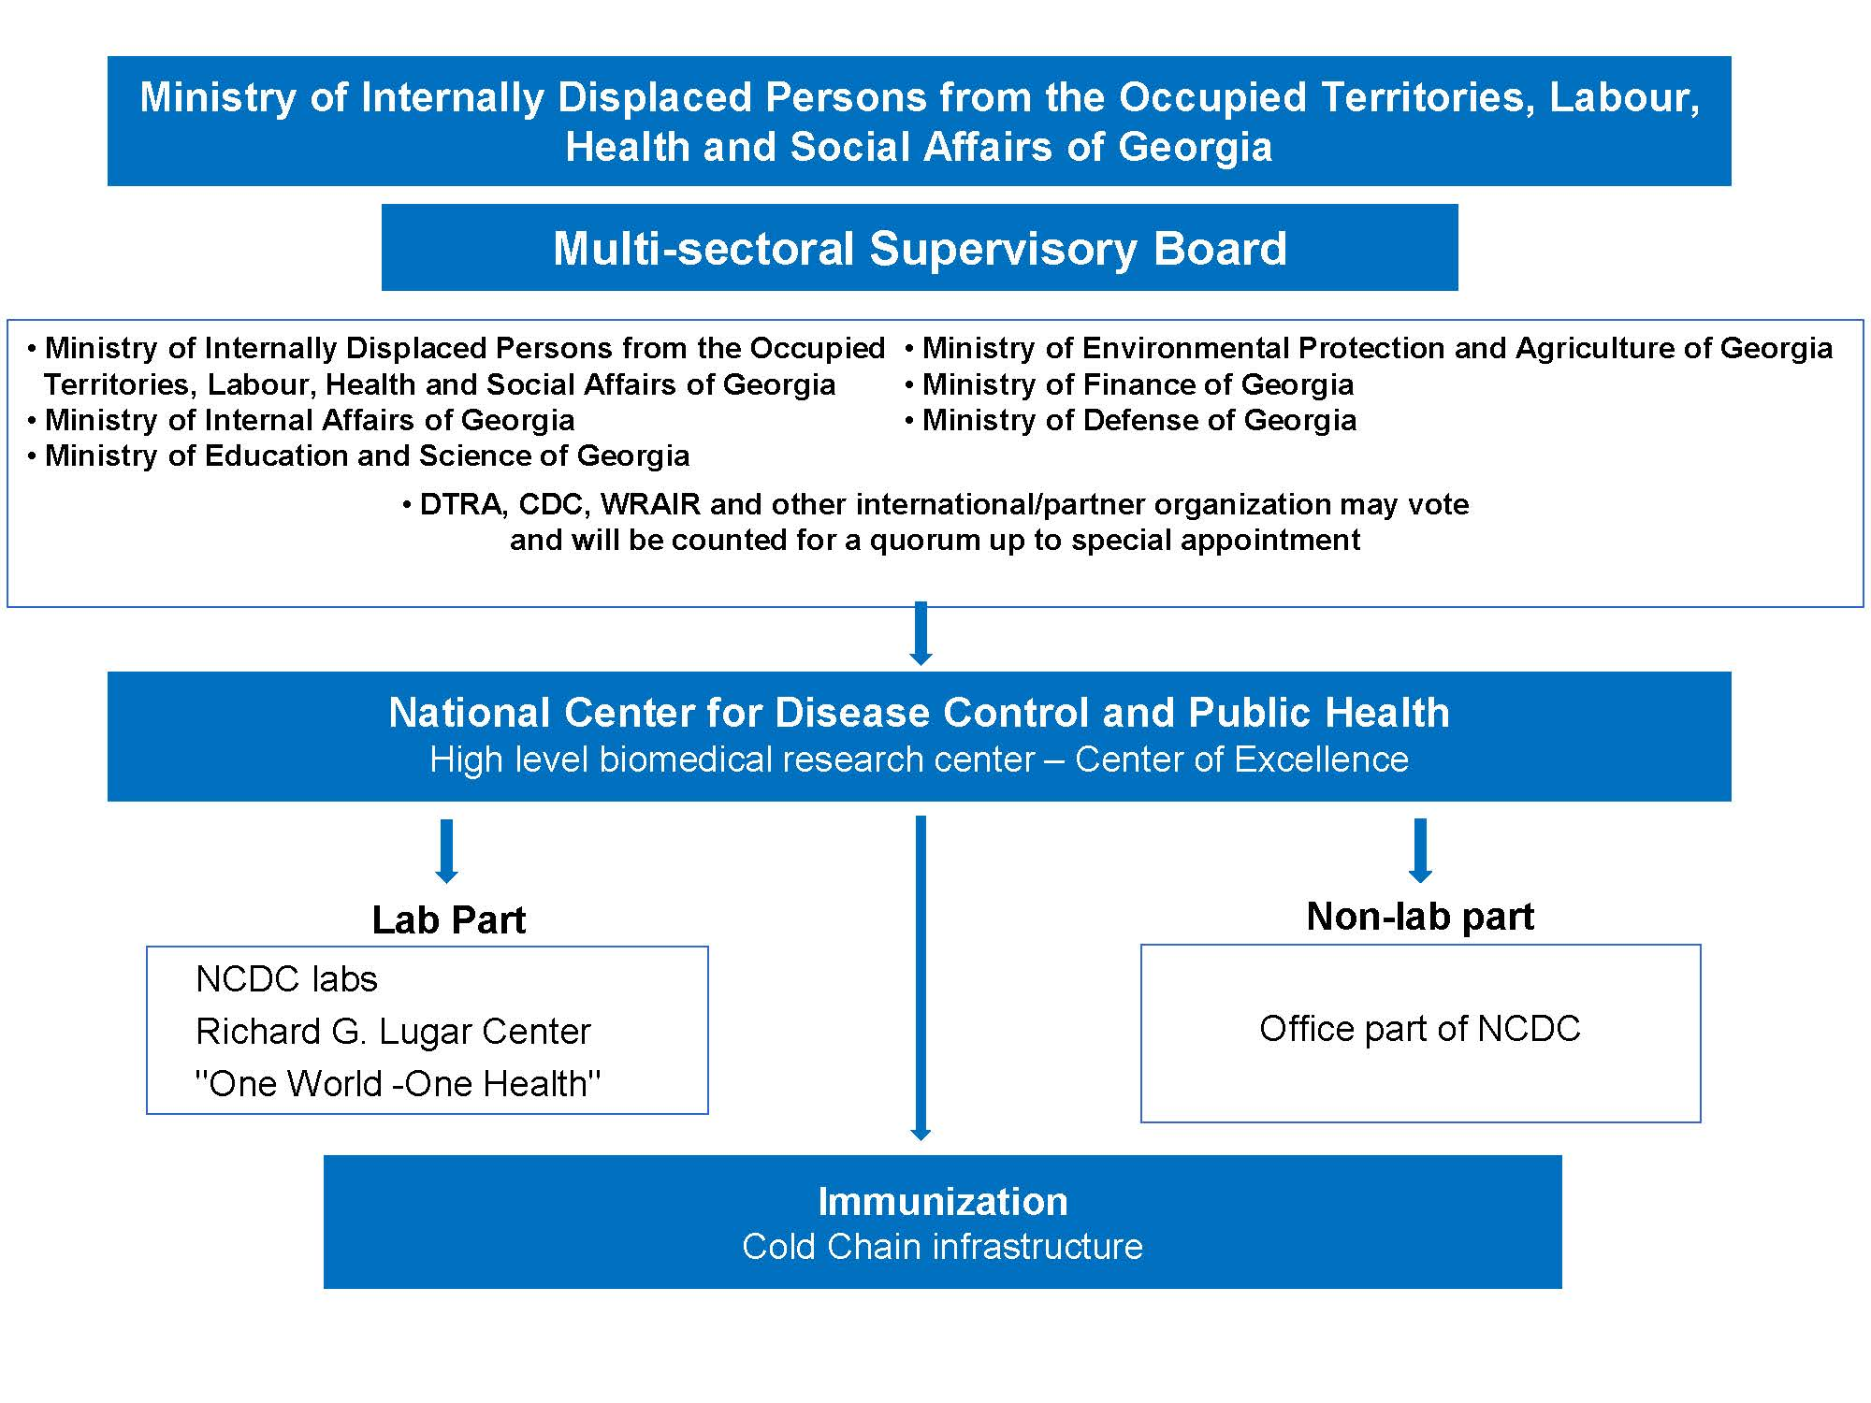

NCDC STRUCTURE

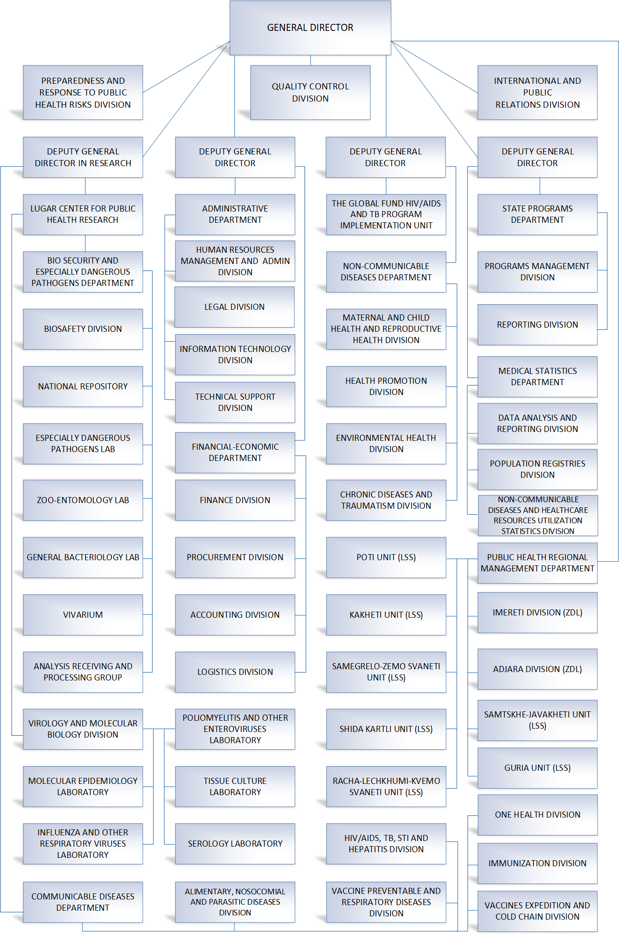

STRATEGIC PRIORITY 1:

DECREASE OF MORBIDITY, DISABILITY AND MORTALITY CAUSED BY COMMUNICABLE DISEASES

Key Achievements

* In 2019, for the first time in the world, Georgia has been granted an honorable title of a model country that fights viral hepatitis, at the International Liver Congress organized inAustria by the European Association for the Study of the Liver (EASL) and International Liver Foundation
* The country has introduced an advance procurement mechanism of the vaccines
* A countrywide assessment of vaccine management system effectiveness conducted
* A vaccine cold chain, systematic approaches of quality management, and appropriate vaccine management standard operating procedures were developed
* Georgiamaintained endemic malaria-free country status
* Within antimicrobial resistance and nosocomial infection control systems, point prevalence surveys were conducted for the first time in 10 clinics of Georgia
* An integrated screening of tuberculosis, HIV/infection and hepatitis C in primary healthcare level was developed and successfully implemented in Samegrelo region
* A video surveillance for treatment of tuberculosis was ntroduced by using special application
* In Adjara, a “Zero Tuberculosis” project started, which aims to establish a “TB Eliminated Island”
* New out-patient clinic for tuberculosis has been opened in Tbilisi
* Primary confirmatory testing by using HCVcoreAg test among beneficiaries enrolled in the Hepatitis C Elimination State Program was successfully implemented
* Archive of bio-bank for collected samples under Hepatitis C Elimination State Program was created
* ISO 15 189 accreditation of serological and molecular testing of Hepatitis C was successfully achieved by external quality control programs
* By 2019, within the annual accreditation by WHO Regional Office for Europe, full accreditation of Measles and Rubella national laboratory was performed
* Main modules of laboratory information management system (LIMS) were developed
* EGFR gene mutation analysis method was implemented (real-time polymerase chain reaction)
* Phenotypic confirmation method of AMR mechanism was validated and established
* Promotion of transition to European AMR standard - EUCAST of the laboratories of the country were implemented

Communicable disease surveillance, prevention and control is the strategic priority of the center, which is implemented by various structural units within their competence. Decrease of morbidity, disability and morbidity caused by communicable disease includes:

* Immunization and cold chain system support, and perfection of organizational-technical matters;
* Monitoring of notifiable communicable diseases under surveillance
* Actions directed towards elimination of measles, and reduction of number of congenital rubella cases
* Retain of endemic malaria free status by providing regular epidemiological and entomological monitoring
* Efforts towards elimination/eradication of diseases that fall under global or European strategies for countries.

1.1 SUSTAINABILITY AND STRENGTHENING OF COMMUNICABLE DISEASE SURVEILLANCE CAPACITY

*Influenza and other respiratory diseases:* Over 2018, epidemiologic and laboratory surveillance of ILI and SARI was maintained by using sentinel sites. As a preparatory activity for influenza season, training of medical personnel was carried out with an emphasis on influenza vaccination necessity.

For influenza season in 2018-2019, the Government of Georgia procured 40 953 doses of seasonal influenza vaccines, and targeted immunization were implemented.

*Bacterial meningitis*: Over the year, epidemiologic surveillance on bacterial meningitis was emphasized on *Haemophilus influenzae type B, Streptococcus pneumoniae,* and *Neiseria meningitidis.* During 2018, surveillance covered patients hospitalized in Iashvili Children's Central Hospital. Probable cases were verified by using latex-aglutination, bacterial and PCR methods.

In 2018 edition of “Sanford Guide to Antimicrobial Therapy” was translated into Georgian and 3000 copies were published, which was distributed free of charge to medical institutions and doctors with the help of public health municipal centers.

As of 2018, Georgia’s 22 microbiological laboratories are already involved in the Central Asia and Eastern Europe Antimicrobial Resistance Surveillance System (CAESAR). The generated antimicrobial resistance data is reflected in CAESAR annual report, issued by WHO EURO.

**State TB management program.** During the reporting period (according to the primary analysis), 2 120 new cases of pulmonary tuberculosis were reported, among them public health centers’ epidemiologists traced 1 301 patients (60%) and 4 220 contacts (3.24 per index patient).

Specific studies were carried out on the basis of JSC National Center for Tuberculosis and Lung Diseases and regional laboratories of the NCDC for laboratory confirmation of presumptive TB cases and monitoring of patients involved in treatment. Through the Ltd “Georgian Post”, 5 874 parcels with sputum samples were transported across the country. For quality control, the pre-and post-lab research process was monitored and selectively verified in the laboratory network of the civil sector, as well as in the Prison and Detention Facilities within the framework of the contract signed with JSC National Center for Tuberculosis and Lung Diseases.

During the reporting period, 15 units of GeneXpert equipment were additionally transferred to 15 multi-profile medical facilities. The GeneXpert study found a positive result in 7% of those surveyed.

In 2018, first-line (fully) and second-line (50% of the total price) TB medicines were procured by the Government, received and transported. Monetary incentives for MDR TB patients (up to 300 patients per month) were provided to improve adherence to treatment for TB patients.

**Global Fund program “Sustaining Universal Access to Quality Diagnosis and Treatment of all Forms of TB in Georgia”.** The country introduced the modern therapeutic and diagnostic methods approved by the World Health Organization: culture on solid and liquid media, rapid diagnostic methods to diagnose TB and MDR TB and drug sensitivity tests. 95% of presumptive TB cases were tested using a rapid molecular method. In total 22675 individuals were tested during the reporting period. From 2018 the country gradually switched to new WHO-recommended cartridge Xpert MTB/RIF Ultra enabling improved case detection among children and people living with HIV.

Both HIV testing coverage (95%) and enrollment in ART of HIV infected TB patients are high. Since the end of 2016, the patients with confirmed TB diagnosis are also tested for Hepatitis C.

From 2017 a pilot project “Integration of Hepatitis C, Tuberculosis and HIV detection at primary healthcare level” was initiated in Samegrelo-Zemo Svaneti region. The project implied awareness raising on TB, HIV and Hep C, development of integrated screening model of Hepatitis C, TB and HIV for PHC settings, engagement of PHC providers, public health units, NGOs and communities in TB/HIV/HCV screening through multilateral trainings in each district. From April 1 active screening was initiated and 88 178 individuals were screened.

The “Zero TB” project was initiated in Adjara region aiming at the creation of the “TB eliminated island” leading to reduction of TB prevalence in the Adjara region and Georgia overall. The initiative covers two directions: early detection through active screening and comprehensive treatment. Since August 2018, 92 visits were performed and 3 326 people were screened, 388 of them were referred for further diagnosis as presumptive TB case, 61 - Hep C antibody test positive and 1 - HIV antibody test positive. The second component was in connection with the case management: job description and protocol were developed. This function was assigned to Adjara region epidemiologists and all of them were trained.

In 2018 TB management guideline and protocols were updated in line with the latest WHO recommendations approved by the Ministry of Internally Displaced Persons from the Occupied Territories, Labour, Health and Social Affairs of Georgia.

**In order to provide quality treatment to all TB patients, including those with TB resistant forms,** the introduction of ECHO model was continued in 2018 to improve health care outcomes through remote control. Treatment success rate in sensitive TB cases is up to 85%, however, despite marked progress, reaching treatment success in MDR cases still remains a challenge for the national TB program. According to the preliminary data, 67% of MDR patients in 2016 cohort were successfully treated (56% in 2015 cohort and 49% in 2014 cohort). Treatment success in XDR cases was 57% in 2016 cohort (56% in 2015 cohort and 32% in 2014 cohort).

With the support of the Global Fund TB Program, 2 mobile outpatient units continued to operate in 2018. These outpatient clinics are located in urban areas, away from the existing TB services, and patients were given the opportunity to receive medication under the supervision of medical staff near their residence.

Video observed treatment (VOT) was introduced through a special application that made surveillance even more flexible. A total of 150 resistant and 47 sensitive patients were enrolled in video observed treatment across the country.

Adherence consultants were contracted for each region with the financial support of the Global Fund TB program.

**In order to improve the infrastructure of TB services,** a new DOT outpatient center was launched in Tbilisi and construction of a second outpatient center began.

**In order to strengthen the management, coordination, monitoring and evaluation mechanisms of the State Tuberculosis Control Program,** a monitoring and evaluation team had been set up in the country, comprising 10 regional coordinators and 3 specialists at the central level (epidemiologist, laboratory specialist and pharmacist). The group performs a quarterly district, regional and central supervision of TB institutions, as well as supervision of primary health care facilities.

**In order to raise awareness of TB,** three projects were implemented with the involvement of the civil sector, namely: providing TB information to various target groups (including religious leaders and parishioners) through an educational campaign. Within the framework of the project, information materials were prepared, information-communication meetings were held in the eparchies and with representatives of the Muslim Division of Georgia. Another project was focused on treatment adherence. Within the project multidisciplinary teams had been formed in Tbilisi, Rustavi, Batumi, Kutaisi and Zugdidi, comprising social worker, psychologist and former patient. Teams inform/educate the patients and their family members about the importance of adherence to treatment, as well as assessing and assisting the patient's individual social and psychological needs. During the project, 219 beneficiaries used

this service, among which the interim loss of follow-up rate decreased almost twice compared to the previous year. The third project captured information-communication-education campaign involving media across the country for general public and high risk groups in order to raise awareness on TB.

In the framework of the State Program on HIV/AIDS Management, 177 569 screening tests were conducted in 2018, including 1 414 retests. Out of them the number of confirmatory tests carried out by immunoblotting method was 755, the confirmatory tests by PCR were 84, in total 688 cases were confirmed (680 were confirmed by immunoblotting and 8 were confirmed by PCR method).

**Global Fund HIV Program: “Strengthening and Sustaining HIV Prevention, Treatment and Care interventions in Georgia”**

During 2018 the Global Fund HIV Program Implementation with a total budget of 18.4 million USD has continued successfully. The Program aims at reducing morbidity and mortality of people who live with HIV in Georgia through quality antiretroviral therapy and care, and prevention of HIV epidemic spread, especially among key populations, through comprehensive prevention interventions.

**4,597**

**People who live with HIV received ARV treatment**

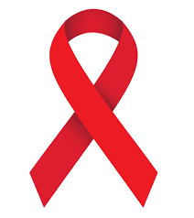

**29,902**

**PWID**

**received comprehensive prevention package services**



**24,420**

**PWID was tested on HIV**



**3,844**

**Female Sex Workers received**

**comprehensive prevention package services**



**7,104**

**MSM received**

**comprehensive prevention package services**



After steady increase in annual cases of HIV during 2015-2016, in 2017 the HIV incidence rate has dropped by 12% and in 2018 it has slightly increased again (by 6%). The interest in HIV testing among key populations has increased with implementation of Hepatitis C Elimination Program that offers population tandem testing on HIV and Hepatitis C.

The main route of HIV transmission is heterosexual contact (46.5%), the injecting use of drugs has moved to the second position attributing to 39.6% of total registered HIV cases. From 2017 relatively increased the percentage of HIV transmission due to homosexual contacts (11.3%) and the trend was maintained in 2018 as well.

Antiretroviral treatment (ART) is provided in Tbilisi and 4 regions of the country (Imereti, Samegrelo, Adjara and Abkhazia). According to the data of Infectious Diseases, AIDS and Clinical Immunology Research Center by the end of 2018 a total of 4597 patients were receiving ARV medicines that is 90% of the target. The country maintains the best in the EECA region achievements for ART adherence (86.4%). For ART support in Abkhazia ARV medicines and treatment monitoring test-systems were provided to Sukhumi AIDS Center through NGO “Zurab Danelia Union Tanadgoma”. In 2018 AIDS patients received free vaccination on hepatitis B (984 patients were vaccinated with 1st dose, 763 with second and 603 with third), influenza (2544 patients) through the State Program.

**Sustainability and Transition Plan Activities:**

In accordance to the National Transition and Sustainability of the Global Fund Activities, in 2018, as it was done during 2015-2017, all first line ARV medicines were procured with the State Funds. In addition, the State has paid for 50% of the second line ARV medicines. For procurement of the medicines the Global Fund Pooled Procurement Mechanism was used, that provides opportunity to procure high quality medicines at reasonable price. The rest of ARVs were procured with the Global Fund money through its electronic procurement platform WAMBO that provides options for better trekking of the order and timely delivery.

In 2018 the National HIV Strategy was updated for the period of 2019-2022 that was used as a guiding document for elaboration of the Global Fund grant program continuation request. The latter received good evaluation from the Global Fund Technical Panel and the NCDC Global Funds implementation unit was asked to develop detailed documentation for grant making (anticipated in I quarter of 2019). The grant amount that Georgia is eligible for the period of 2019-2022 is by 50% less than the previous funding which indicates for the need of the corresponding increase in the State Funding of the national HIV response activities.

**Harm Reduction Needle and Syringe Program of Harm Reduction**

Population size estimation study conducted among People Who Inject Drugs (PWIDs) in 2017 indicates the growth of this population. If in 2014 the same type of study estimated having about 49700 PWIDs in the country, according to the population size estimation study of 2017, this number has increased up to 52,500, and by population based prevalence of injecting drug as Georgia is rated third worldwide, which point to high importance of harm reduction programs implementation in Georgia.

In 2018 total of 16 service centers (including 2 new centers) were delivering needle and syringe program services in 13 cities of the county (Tbilisi, Rustavi, Gori, Telavi, Samtredia, Kutaisi, Zugdidi , Poti, Ozurgeti, Batumi, Sokhumi, Borjomi, Akhaltsikhe). During 2018 total of 38.240 beneficiaries received harm reduction services, 24,420 were tested on HIV (number of HIV positive cases 33), 23,451 on hepatitis C (positivity rate 22%), 18515 on hepatitis B (number of positive beneficiaries was 650, 3.5%). The program personnel has identified 59 cases of syphilis infection and 18 cases of active TB infection. HIV prevention service package from which one mandatory service is needle and syringe distribution, was provided to 29,902 PWID. Number of distributed syringes was 3,763,000, 465000 condoms were provided to beneficiaries. In addition 14000 naloxone single doses for overdose prevention and up to 30 000 informational materials were distributed.

**FSWs and MSM population coverage with HIV prevention Services:**

In 2018 3,844 FSWs were reached by comprehensive HIV prevention interventions, the same year the number of MSM reached by the program was increased from 5517 in 2017 up to 7104 in 2018.

**Pre-exposure HIV prophylaxis (PrEP) program among MSM:**

Georgia was the first in EECA region that started PrEP among MSM in 2017. The detailed protocol of the program was elaborated, the social media awareness raising campaign of the program was implemented and the official launching of the program was organized. At the end of 2018 the number of PrEP beneficiares has increased up to 106 individuals. From November 2018 the access to PrEP was expanded to regions and MSM living in Batumi and Kutaisi were able to get inrolled in the program.

**Development of unified HIV prevention electronic system:**

In 2018 the most significant achievement of the program was development of HIV prevention real time electronic system, that along with the Global Fund AIDS program makes it possible to reflect the results of HIV screening tests, consultations and other service delivery, in case of registration and data entry to database by relevant service providers.

**Scientific/operational studies:** In 2018 population size estimation (PSE) and Integrated Behavior and Biomarker prevalence survey (IBBSS) was conducted among MSM in Georgia by Curatio international Foundation and NGO Tanadgoma within the Global Fund HIV Program. The same year a new study was initiated by Foundation for Innovative Diagnostics (FIND) to assess effectiveness of HCV point of care NAT testing for improving access to and utilization of hepatitis C confirmatory testing and treatment services among PWIDs who attends Harm Reduction service centers for hepatitis C testing. Primary data show the efficiency of this approach and significant support to the Hepatitis C Elimination Program.

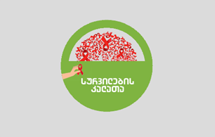**Charitable Event:** On December 1st of 2018 a children’s charity Art event “Wish Basket” was organized within the Global Fund HIV program to support HIV positive children and those who lost parents and/or guardians due to AIDS. Famous Georgian artists have donated their art works in support of children. Based on the individual needs of children, Christmas presents were purchased with funds generated during the event and distributed.

### Work done by the Lugar Center in direction of Communicable Diseases

### Over 2018, the Lugar Center registered a total of 30 968 samples; including human samples -21 619, environmental samples – 8 740, genetic materials – 30, microbial cultures for preservation and confirmation – 579, including:

Testing on influenza and other respiratory viruses: 954 nasal and throat samples were received at the Lugar Center.

During the reporting period, 46 614 serological tests were performed within different projects and programs by the serologic laboratory of the Lugar Center.

In 2018, serologic laboratory successfully gained ISO 15 189 accreditation till January 5, 2020 in Hepatitis, Measles-Rubella and Rotavirus serology testing.

1.2 IMPLEMENTATION OF ONE HEALTH APPROACH IN THE COMMUNICABLE DISEASE SURVEILLANCE

Implementation of One Health approach for the surveillance and control of communicable diseases became a priority for the Center. This direction is covering zoonotic diseases, AMR, vector-borne diseases and monitoring of vectors as well as analysis and review of information with the involvement of all relevant stakeholders, organizations and units. For the implementation and coordination of above mentioned activities, a division of One Health was established in 2019 at the NCDC.

On December 21st, 2018, the NCDC held “One Health Day conference – strengthening capabilities in human, animal and environmental sphere”. The event was officially registered on One Health Day website.

1.3 ELIMINATION/ERADICATION OF DISEASES DETERMINED BY GLOBAL STRATEGY OR THOSE THAT ARE IMPORTANT FOR THE COUNTRY

In order to maintain the status of **polio free country**, surveillance on poliomyelitis and Acute Flaccid Paralysis (AFP) had been continued. Size of a target group for AFP surveillance was (children aged 0-14) 649 100. During 2018, not a single case of wild poliovirus infection was registered in Georgia. 8 cases of AFP were detected and studied in 0-15 age-group.

**In order to maintain surveillance on measles/rubella/congenital rubella syndrome, surveillance on each nosology was continued.** An increasing trend, which started at the end of 2017, continued in 2018. Each case is reported to WHO Regional Office for Europe. 2 200 cases of measles were registered in 2018 (94 - in 2017); Incidence per 100 000 population – 60 (2017 – 2.5). In comparison to 2017, there was 24-fold increase of incidence in 2018. 3 lethal cases were registered in 2018. Kvemo Kartli Region – 10 month-old, respectively not vaccinated, laboratory confirmed; Kakheti Region – 11 month-old, respectively not vaccinated, epidemiological link was confirmed; Imereti Region- 16 year-old, not vaccinated, laboratory confirmed.

42% of registered cases were not vaccinated, 6% vaccinated with one and 2%, with two doses, while in case of 50% it was not possible to determine vaccination status.

1 414 cases (64%) were hospitalized. Out of hospitalized cases, 797 (56%) were of >20 age group. Complications were registered in 257 (12%) cases. Out of them, 158 (61%) had pneumonia, 49 (19%) - diarrhea, 50 (20%) - other complications.

Due to the situation in the country, respective preventive measures were planned precisely and deliberately and have being carried out (including immunization, surveillance and communication). Apart from the routine vaccination, in children aged 1 and 5, unplanned vaccination was conducted for 45 395 persons during 2018, while in the first 6 months of 2019 more then 140 000 persons were vaccinated.

No cases of rubella were registered as well as no congenital rubella syndrome was detected in 2018.

**In order to maintain malaria-free status**, 11 probable (presumptive) cases were investigated, out of which 9 were lab-confirmed (7- tropical and 2 - P.vivax). All of them were imported from African and Asian countries. Out of 9 confirmed cases, 3 were foreign citizens and 6 were citizens of Georgia. All of them were visiting above mentioned regions for working purposes. No lethal cases were registered.

During 2018, 1 473 malaria suspected cases were screened with thick blood smear by 13 public health municipal centres and specialists in malaria zones of Georgia. 10% of results (156 samples) of the studies carried out across the country (thick blood drop and smears) were retested at the Center's Laboratory.

**Congenital syphilis and HIV/AIDS mother to child transmission**

For the elimination goals, throughout the country 46385 pregnant were screened for syphilis - this is 91% of total registered pregnant. According to EIDSS database syphilis seropositive (RPR+) 141 cases were detected during the reporting period. Out of them 72 pregnant had confirmed disease (51%). According to this data, total percent of pregnant infected with syphilis is 0.15% of all pregnant population. Full-fledged treatment was completed in 85% of all infected pregnant. According to EIDSS in 2018 5 cases of congenital syphilis were registered.

In recent years fluctuation in testing coverage is yet unexplained. There is no gap in test kit supply and logistics. One reason could be that birth registry has incomplete information and data from laboratory settings and/or OB service providers.

**Hepatitis C Elimination State Program**

Following steps were madeaccordingto **Hepatitis C elimination strategy:**

* Hepatitis C screening protocol was developed and implemented
* Public health municipality center epidemiologists and medical facility representatives were trained on Hepatitis C screening protocol and electronic module of Hepatitis C
* In 2018 Hepatitis C profile was twice revised and published in Georgian and English languages
* Regular monitoring of “Hepatitis C elimination strategy 2016-2020” implementation was conducted
* NOhep program was coordinated with Hepatitis World Alliance support
* The NCDC was actively involved in scientific committee work, including reviews of study proposals and development of session minutes. Two proposals out of total three presented by the NCDC, were funded. Preparatory works started right after the approval in 2018 and will continue in 2019.

“Hepatitis C associated hepatocellular carcinoma detection and characterization among patients with liver and biliary tract cancer in 2015-2016 in Georgia” study was initiated in partnership with US CDC.

With the CDC support “Diagnosed with acute viral hepatitis and jaundice hospitalized cases retrospective study” was implemented. The goal of the study was development of recommendations for strengthening and improvement of acute viral hepatitis epidsurveillance system. Study results were presented at the 4th TAG meeting and the recommendation were developed, to be implemented over 2019.

Since 2018 screening points started functioning on the regular basis in the branches of LEPL Public Service Hall under the Ministry of Justice of Georgia. 400000 Hepatitis C screening test kits were procured with relevant laboratory consumables.

According to Hepatitis C Electronic Screening Database, the total number of Hepatitis C tests within the Hepatitis C Elimination State Programand other state programs amounts to 874,984-ს (505,718  unique beneficiaries were tested), out of which 25 187 (2.93%) antibody positive cases were detected (number of unique beneficiaries with positive result amounts to 23.718 - 4.69%).Within the program, the ratio of the number of outpatient Anti HCV tests to the annual target number (300,000) is 110% (328 557 outpatient tests).

In 2018, screening positive samples (total of 17649) were sent for further investigation to Lugar Center. With CoreAg confirmatory testing 12 963 cases were revealed as positive on HCV infection, marginal results were revealed in 240 cases and negative – in 4446 cases, that in total amounts to 4 686 cases, out of them 324 samples were rejected. Accordingly molecular testing was carried out on 4 362 samples with negative and marginal results. HCV RNA testing revealed 728 positive results and 3 634 negative results. In total out of 17 649 probable positive cases 13 691 were confirmed to have active HCV infection.

**Epi-surveillance of rabies (hydrophobia) cases:** Rabies remains to be an endemic disease in Georgia. In 2018, 2 lethal cases were registered and the number of persons who had contact with suspect rabid animal, reached to maximum - 59 420.

Number of admissions to healthcare facilities due to bites, scratches or contact with saliva of animal is increased in 2018 by 7 412 (12, 4%), in comparison to 2017. Admission is increased in all regions all over the country: in Tbilisi by 14,5%, Imereti - 14,2%, Mtsketa–Mtianeti – 13.6%, Samegrelo -12.7%, Shida Kartli – 12,3%, Samtskhe-Javaheti and Raja-Lechkhumi – 11,7%, Guria–10,6%, Kvemo Kartli – 10%, Kakheti – 9% and Adjara 8,4%.

1.4 ANTIMICROBIAL RESISTANCE AND INFECTION CONTROL

In accordance with nosocomial/healthcare associated infection surveillance strategic plan (ministerial order N01-54/o, 22nd of February, 2018), in multiprofile clinics of Tbilisi, Kutaisi, Batumi, Zugdidi and Telavi (in total of 65), the first and the second stages of monitoring of infection prevention and control measures were conducted by using standard questionnaires. During the same period, together with the LEPL State Regulation Agency for Medical Activities, 23 in-patient facilities were monitored on violations in infection control system (ministerial order N01-5/n, 7th of February, 2018). As a result of regular monitoring conducted at in-patient facilities, number of notifiable nosocomial infections had 4,2-fold increased and reached to 535 (127 in 2016; 334 in 2017), and compared to 2017 – detection-registration had 1,6-fold improvement. Despite the most of registrations occurring in hospitals of Tbilisi (82% of all cases of NI), the widening of geographic area is apparent.

For hospitals’ and public health centers’ epidemiologists in Tbilisi, Kutaisi, and Batumi, 6 trainings were conducted on study design, data collection and analysis of point prevalence survey (PPS) on antibiotic usage, healthcare associated infections, and antimicrobial resistance. Such PPS surveys took place in 14 intensive care units of 10 hospitals in Tbilisi, Kutaisi, and Batumi. The data analysis had shown following results: 28.6% of patients had healthcare associated infections, 62.2% of them received treatment by various antibiotics empirically, and 16 patients (34.8%) received two or more antibiotics empirically. The most frequently used empiric antibiotic is ceftriaxone (37.0%).

Medical personnel of five polyclinics and six hospitals in Tbilisi, Kutaisi, and Batumi, received trainings on healthcare associated infections, their prevention and control, rational use of antibiotics and antimicrobial resistance.

1.5 DEVELOPMENT AND STRENGTHENING OF SAFE BLOOD SYSTEM

During the reporting period, a total of 86 294 donations were performed by blood banks enrolled in the State Safe Blood Program. Voluntary non-remunerated blood donations comprised nearly 27% (23 500 donaitons) of total donations whereas 60% (52 165 donations) and 12% (10 629 donations) represented paid and family/replacement types of donor respectively. Out of them, 68 donations tested screening positive for HIV/AIDS (20 cases were confirmed), 528 for anti-HCV, 469 screening positive results were observed for hepatitis B and 348 for syphilis.

In terms of retrospective laboratory quality control, a total of 2947 blood samples were retested for HIV/AIDS, Hepatitis B, Hepatitis C and Syphilis.

Within the framework of the National Campaign for regular non-remunerated donors’ attraction and promotion, the large-scale informational and educational activities were undertaken.

1.6 IMMUNIZATION

As of 2018, country fully switched to advance procurement mechanisms for National Immunization program, to eventually ensure the continuous supply of vaccines.

The temperature mapping study had been conducted for five vaccine cold rooms at the national vaccine store and temperature monitoring study was exercised to monitor vaccine conditions during transportation and storage at all levels of the cold chain; Effective vaccine management system assessment was conducted throughout the country.

In order to institutionalize the best vaccine management practices, the standard operating procedures have been developed to ensure systematic approach to vaccine cold chain management and quality control. The trainings on immunization in practice for healthcare providers and mid-level managers / district public health specialist were conducted. Total around 2000 specialist were trained.

Routine immunization activities aimed at the target groups identified through the National immunization calendar.

**Target population for 2018, countrywide, by age groups**

|  |  |  |  |
| --- | --- | --- | --- |
|  | 2017 | 2018 | Compared to 2017 |
| Estimated birth rate | 53 146 | 50 682 | -2 464 |
| 0-12 month infants | 51 891 | 49 145 | -2 746 |
| 12-24 months toddlers | 52 387 | 51 060 | -1 382 |
| 18-24 month toddlers | 52 087 | 48 335 | -3 752 |
| 5 y.-5 y. 11 months 28 day old children | 53 103 | 54 964 | 1 861 |
| 9 year old girls (born in 2008 ) | 10 652 | 10 652 | - |
| 9 year old girls (born in 2009) |  | 10 500 | - |
| 14 year old children | 38 183 | 38 542 | 359 |

Vaccination coverage increased for all major antigens compared to last reporting year. Average growth was 3.7%.

The national target of 95% coverage was achieved for 4 antigens (BCG, Hepatits B0, MMR1 and MMR2), compared to 2017 when only MMR1 coverage met this target. In addition, compared to 2017, an increase in coverage with MMR1 and MMR2 was observed (3.2% and 5.8% respectively). The coverage with MMR1 under 24 months had improved in 8 out of 11 regions, decreased coverage was observed only in Imereti (-1.4%), Mtskheta-Mtianeti (-0.8%) and Racha-Lechkhumi (-2.4%) regions.

The coverage with HPV vaccine (introduced in December 2017 as a demo project in Adjara region, Kutaisi and Tbilisi) for 2008 and 2009 target populations is not high, especially for 2009 cohort. Although the coverage was quite high in Adjara region and amounts to 86% with both doses.

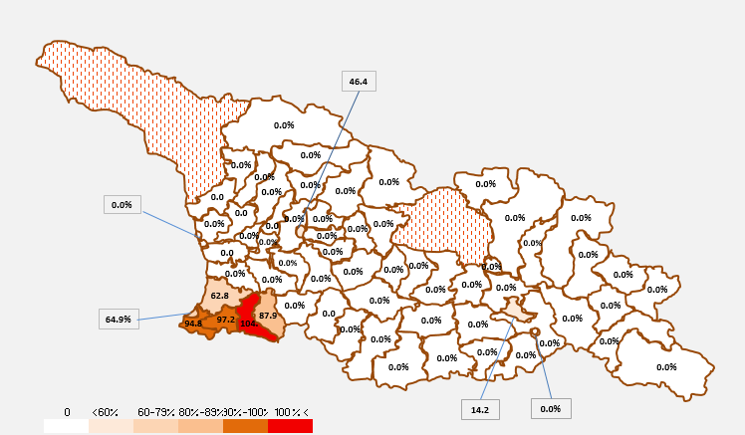

***HPV2 coverage for 2008 target population, 2018***

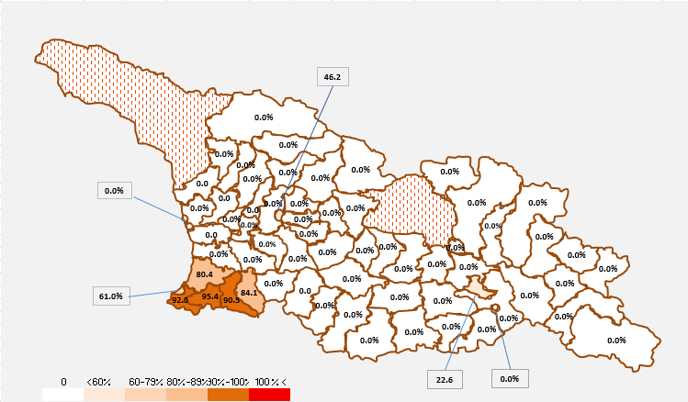

***HPV1 coverage for 2009 target population, 2018***

In 2018, compared to previous year coverage with third dose of Hexavalent vaccine increased by 0.3%. It is also worth to note that drop-out rate for Hexa1/Hexa3 has decreased by 0.3% (2017- 6.6%; 2018 – 6.3%). Another positive change to observe was that drop-out rates for all regions were under recommended 10% and did not exceed 9.7%, as compared to previous year.

The refusals to vaccinate decreased by 1.2: 2017-124 and 2018 – 101, which is explained by systematization of refusal registration through supportive supervision and adoption of the standard refusal forms.

Contraindication and refusal rates are relatively high in Imereti, Samegrelo districts and Tbilisi. Although it could be that some other districts have underreporting issues.

The epidemiological activities aiming at the reduction of Measles cases, 39 317 beneficiaries were vaccinated throughout the country in 2018:

|  |  |
| --- | --- |
| **Region** | **2018** |
| Adjara | 4 934 |
| Kakheti | 3 205 |
| Imereti | 4 922 |
| Samegrelo | 4 624 |
| Shida Kartli | 2 646 |
| Kvemo Kartli | 5 225 |
| Guria | 995 |
| Tbilisi City | 8 815 |
| Samtskhe-Javakheti | 2 697 |
| Mtskheta-Mtianeti | 858 |
| Racha-Lechkhumi | 396 |
| **Georgia** | **39 317** |

*Other Vaccine preventable diseases:* Capacities of the Lugar Laboratory for pertussis serologic testing have been improved since 2017. 558 cases of whooping cough have been registered in 2018, which is twofold increase compared to previous year.

31 cases of mumps were registered in 2018, and incidence had increased by 14,3% compared to similar period of previous year.

Out of 7 cases of tetanus registered in Georgia for 2018, 5 were lethal (71.4%). One of the infected is a child (14-year-old), incompletely vaccinated (last, 6th revaccination not received), 5 adults were unvaccinated (64, 77, 82, 84 and 85 year-old) and the status of one case was not identified (29 year old).

Following the introduction of rotavirus vaccine, sentinel surveillance data show decreased in rotavirus diarrhea rates among acute diarrheal diseases. in 2018, as well as 2017 and 2016 no diphtheria cases were observed in Georgia.

Major challenges

* Maintenance of sensitive surveillance system, in order to be aware of real-time epidemiological situation in the country
* Maintenance of EIDSS sustainability
* Development of event-based surveillance
* Multisectoral partnership
* Strengthening of AMR surveillance within One Health approach
* Introduction of HPV vaccination throughout the country among girls of age 10, 11, and 12
* Improvement of attitudes, knowledge and awareness among population concerning routine immunization
* Under exisiting drug policy presenting complex environment to attract PWIDs into Needle and Syringe Program
* High level of stigma and discrimination in population concerning HIV
* Low detection of HIV cases and high percentage of disease detection at a later stage
* Perfection of quality control in all laboratories
* Refining and full implementation of the Laboratory Information Management System (LIMS)
* Introduction of new methods
* Proper arrangement of storage spaces and comprehensive use of electronic module.

STRATEGIC PRIORITY 2:

DECREASE OF MORBIDITY, DISABILITY AND PREMATURE MORTALITY CAUSED BY NON-COMMUNICABLE DISEASES

Key Achievements

* Health Behavior School Survey (HBSC) was conducted at123 schools throughout Georgia
* Pilot study on “Selective Abortion in Georgia” was conducted in Kakheti region
* Final report on non-communicable diseases risk-factors of the STEPs survey was prepared
* Massive screening for arterial hypertension was conducted (May-measurement month) and more than 11 000 persons were screened
* Enforcement of tobacco control law launched
* Universal newborn hearing screening was implemented at all maternity houses
* Health promotion state program’s core contents and budget were increased. New components were added. Collaboration with other organizations working on health promotion and communication was intensified

2.1 SURVEILLANCE OF NON-COMMUNICABLE DISEASES

Non-communicable Disease Strategy and 2017-2020 Action Plan endorsed by the Government of Georgia in 2017 is a roadmap and consistent guideline for prevention and control of four major non-communicable diseases in the country: cardiovascular diseases, cancer, chronic respiratory diseases and diabetes.

**Cardiovascular diseases:** Increase in prevalence of cardiovascular diseases in Georgia, specifically – arterial hypertension, ischemic heart diseases, cerebrovascular diseases, is likely associated with the increased reference to medical services and improved control of those diseases; In terms of increased reference to the medical services “May – measurement month” played a vital role; Although, arterial hypertension is still the most critical part among cardiovascular diseases. It represents 60% of morbidity. The most recent second peak increase of prevalence was in 2017.

*Cardiovascular diseases prevalence by regions, 2017*

|  |
| --- |
| By the initiation of international society of hypertension, global campaign for hypertension screening “May measurement month” was conducted. Georgia participated in this campaign in coordination with the NCDC and Georgian Society of Hypertension. If in 2017 the campaign covered 6 144 adults in Georgia, in 2018 it already covered 11 000 adults. The campaign was structured as voluntary based which involved around 500 doctors. The campaign was also expanded by educational activities. |

Cancer: According to the cancer population registry, 8 731 new cases of all localization cancers (including in situ cancers) are registered in 2017 (indicator for 100 000 inhabitants – 234.3).

*New cases of all localization cancers, Georgia 2007-2017 (in situ stage of cancer is taken into account)*

In 2017, 57% of new cases of all localization cancers were detected in females, 43% - in males; incidence in males was 212.5 and in females - 254.4. Only 40.2% of cancer were registered at stage I and II.

In 2017, five most prevalent cancers among woman were: breast, thyroid, corpus uteri, colorectal and cervix uteri cancer.

*Five most frequent cancer stages among females*

In 2017, five most prevalent cancers among males were: trachea/bronchus/lung, bladder, colorectal, prostate and stomach cancer. According to data on cancer stage at registration shows that lowest rate for registration at stage I and II is for trachea/bronchus/lung cancer and stomach cancer (9.1% and 13.7% respectively).

Assessment of age related factors among males shows that, in all age groups before age 79 trachea/bronchus/lung cancer has a leading position. Prostate cancer comes thereafter. Incidence of all the above mentioned cancers reaches maximum rate in 65-79 age groups.

*Five most frequent cancer stages among males*

It is important to mention, that coverage by cancer screening program is still considerably low in Tbilisi as well as in the regions.

**Chronic respiratory diseases:** In 2017, total 101 259 patients were registered with chronic respiratory disease diagnoses (prevalence – 2 717.3) in Georgia. 55 587 patients were registered with first lifetime diagnoses (incidence – 1 491.7). In 2012-2017, there is a positive dynamics for chronic respiratory disease prevalence and incidence. In 2017, there was a minor decrease in incidence rate.

Most frequent new cases for chronic respiratory diseases in 2017 were chronic and uncertain bronchitis and allergic rhinitis.

**Diabetes Mellitus:** Diabetes Mellitus represents one of the major healthcare problems among other non-communicable diseases. Disease prevalence in the country in quite high. According to the International Diabetes Federation atlas edition 8 (2017), about 232 000 (163 500 - 368 500) people have Diabetes Mellitus in Georgia. And in the 20-79 year age group prevalence of Diebetes is 8.1% (5.7%-12.8%). Recently there is a tendency for increased prevalence of Diebetes in Georgia, main factor of which is increased prevalence of Diabetes Mellitus type II and it is possibly associated with the improved control of the disease. According to the data from non-communicable diseases risk factor survey (STEPS-2016), increased fasting glucose levels (6.1-7.0 m mol/l) among 18-69 year age group was seen in 2% of the population and high levels of fasting glucose (>7 mmol/l) - in 4.5%.

By the end of 2017, there were 90 599 patients registered with Diabetes Mellitus in Georgia (prevalence– 2430.2). 21 822 patients had first in the lifetime diagnoses (prevalence rate on 100 000 – 585.4). In 2017 Diabetes Mellitus type II diagnoses had 65 721 patients (rate - 1762.9), out of which 12 931 (rate - 346.9) was first in the lifetime; Whereas 17 567 cases (rate- 471.2) were registered with Diabetes Mellitus type I and out of which 2 776 (rate - 74.5) were new cases.

In 2017, among youth under age 15 prevalence rate for Diabetes Mellitus type I was 55.5 and in 2016 it was 51.9; Incidence of Diabetes Mellitus type I among youth before age 15 in 2017 was 23.1 and in 2016 – 19.0.

Accidents and traumas: Traumas represent a fourth leading cause of death in Georgia. In general, in trauma structure road accidents are on the leading position. In Georgia, road accidents show decreasing tendency and in 2017 rate decrease by 12% compared to 2016. These positive dynamics were probably influenced by legislation changes on road safety in 2016.

In 2018, strengthening of non-communicable diseases and trauma prevention and control was advocated in primary healthcare and public health sectors; World days for non-communicable diseases and it’s risk factors were marked to increase awareness and support prevention as well as participation in TV shows took place.

2.2 MATERNAL AND CHILD, ADOLESCENT AND REPRODUCTIVE HEALTH

During 2018 following activities were conducted:

• 123 schools throughout the country participated in the Health Behavior School Survey (HBSS). 4 242 student of 11, 13 and 15 years of age were involved. Data was integrated into the international database;

• Pilot study on “Selective abortion in Georgia” was conducted in Kakheti region;

• Maternal mortality epidemiologic survey was conducted;

• There was an active cooperation with the Coordination Council for Maternal and Child Health of Georgia and with the Perinatal Regionalization Council within the NCDC existing competences;

• Currently work on analyzing data from birth registry, creating concept and design for future registries, defining priorities and financial needs;

• Participation in the international reporting within the NCDC existing competences;

• Family planning communication strategy was elaborated in collaboration with the NGO “Tanadgoma”;

• According to the routine data quality assessment protocol, observation and control of the maternal and child health and reproductive health indicators was conducted.

Strengthening surveillance for mortality of reproductive age (15-49 years) women and children under 5 years through EIDSS: In 2017, only 23.4% of death cases of woman of reproductive age and 35% of death cases of children 0-5 years of age was entered into EIDSS system by the public health centers. Insufficient data provided centrally by the EIDSS system unambiguously indicate to the existing problems in the system. In particular, transfer of information on death cases between local medical facilities and village doctors and public health centers is still problematic.

Epidemiological survey of maternal mortality: In order to study maternal death cases and calculate the rate, NCDC studied 20 probable maternal death cases throughout Georgia. Retrospective and descriptive research was based on the maternal mortality active surveillance. For the research several techniques were used: (1) examination of the medical history, (2) collecting information in the family of the woman using verbal autopsy questionnaire, (3) in-depth interviews with medical personnel. During the research of households dividing families by quintiles according to income was used.

In 2017, 17 death cases associated with pregnancy were observed in Georgia. According to the national data, maternal mortality was 13.1 per 100 000 live births.

Several indicators of reproductive health are improved in the country, such as on time referral to antenatal services which is referring before 12 weeks of gestation and 4 antenatal visits during pregnancy. The rate of labor before 20 years of age has decreased. The rate of induced labor is still high (using Cesarean section, forceps and vacuum extractor).

It should be noted, that within the frames of the Maternal and Child Health State Program, the NCDC implements screening of the pregnant women for HIV, Hepatitis C and B, and Syphilis; prevention mother to child transmission of hepatitis B; newborn hearing screening components, in particular: (a) ensures procurement of screening tests, consumables and human hepatitis B immunoglobulin and their delivery to service provider medical institutions through regional public health centers, (b) provides funding for in-depth diagnostic and follow up services for newborns identified by primary hearing screening at maternity houses in order to ensure early detection of children with hearing impairment and their timely inclusion in the treatment and rehabilitation programs.

It is important to mention that the NCDC within the “maternal and child health” state program is testing Hepatitis B & C, HIV/AIDS and syphilis during pregnancy; ensuring prevention of mother to child infection of Hepatitis B virus; and newborn hearing screening. In particular, purchasing screening tests/other material and immunoglobulin for Hepatitis B and delivering them to the medical service providers through public health centers. Additionally, for early identification and early inclusion in treatment/rehabilitation programmers covering costs for further diagnostic procedures and follow up in newborns who were diagnosed with hearing deficiency at initial screening.

2.3 HEALTH PROMOTION

“Health Promotion” 2018 state program included 7 components:

1. Strengthening of tobacco control;
2. Education on healthy diet;
3. Awareness raising on excessive use of alcohol;
4. Supporting physical activity;
5. Supporting Hepatitis C prevention and public literacy;
6. Supporting mental health and prevention of drug addiction;
7. Strengthening and popularization of health promotion.

During the business year numerous activities in all components were conducted, including:

* Effective communication campaign “Smoke free Georgia from May 1st” was conducted;
* In order to evaluate enforcement of tobacco control legislation more than 7800 institutions, 4800 retail stores, 2400 public transport and advertisement locations were monitored (40% in Tbilisi and 60% in the regions). Observation questioner was prepared. For monitoring in the different institutions, mobile application was created which is integrated to the GPS system and compatible as with Android as well as with IOS;
* Training was held for law enforcing institutions on tobacco control legislation;
* Pilot training for school teachers was held on tobacco control issues;
* Tobacco quit line 116001 is operating 7 days a week 8 hours per day;
* For “popularization of health promotion” activities/sport events were organized to promote physical activity;
* Videos on alcohol abuse and harms in youth were prepared for the Cannes Lions International Festival of Creativity;
* Information banners were placed in Tbilisi metro stations for one month;
* Within the component on “supporting Hepatitis C prevention and public literacy” printed and video materials created according to the strategy were tested on target population using focus groups: patients with Hepatitis C, representatives of high risk groups and general population;
* Various activities were conducted for the world Hepatitis C day and “STOP C” communication campaign to raise awareness on Hepatitis C in the population;
* Informative text messages was sent to the public;
* Communication campaign strategy plan was prepared for “supporting mental health and prevention of drug addiction” component; Educational campaign was running using social media (Facebook page “understand me” <https://www.facebook.com/NCDCmentalhealth/>);
* On inclusion topic, photo stories and blogs were prepared using contest format involving youth, where 6 works were selected and published;
* For creative activities, works were prepared (web page and mobile application) on promoting regular blood donation presented at the Cannes Lions International Festival of Creativity;
* Activity for voluntary blood donation day was held.

2.4 STRENGTHENING OF TOBACCO CONTROL

Tobacco use is the major risk factor for cardiovascular diseases, cancer, chronic pulmonary obstruction and diabetes. 94% of lethal cases in Georgia are associated with the diseases mentioned above. Huge part of healthcare expenditures in Georgia are associated with diseases caused by tobacco use. In order to save future generations and protect their right for health, the Parliament of Georgia adopted a new generation tobacco control law in May, 2017 – tobacco control, advertising, broadcasting, lottery, gambling and money earning games; Enforcement started on May 1st, 2018. Legislative reform of Georgia is aligned with the responsibilities described in tobacco control strategy and national action plan; and importantly, it is also aligned with the association agreement between the European Union and the European Atomic Energy Community and their Member States, of the one part, and Georgia, of the other part.

Main changes resulted by the reform are:

* Excluding tobacco industry interests and providing transparency on relationships between tobacco industry and public organizations/figures in healthcare during preparing, making and establishing decisions;
* Tobacco smoke free places (except casinos, cigar bars and airports) from May 1st, 2018;
* Banning any kind of advertisement, popularization and sponsorship of tobacco products (including via internet) from May 1st, 2018;
* Banning showcasing of tobacco products and it’s accessories so they are visible from outside from September 1st, 2018;
* Smoke free stadiums from May 1st, 2020;
* Banning showcasing of tobacco products and it’s accessories inside the shop from January 1st, 2021;
* Plain packaging with pictorial warnings from January 1st, 2022.

“For cigarettes with and without filters which are produced to be marketed in Georgia norms for released substance (nicotine, tar, carbon monoxide), measuring and regulating rules, health warnings for the packages and its printing norms” Pictorial warnings were adopted by the Government of Georgia in 2018, with decree #14.

Tobacco control law enforcement monitoring is conducted by the health promotion state program tobacco component.

In 2018 monitoring results showed that, enforcement of the tobacco control law in the institutions was 96%, in retail stores – 85% and in public transport – 93%. In this period various activities were conducted: trainings for enforcing agencies as well as for public health centers were held; Statutory law was adopted; Media campaign was held; Mobile application “quit smoking” is active; In the mobile application of 112 tobacco component was added, etc.

**Major Challenges**

* Incomplete monitoring of non-communicable diseases
* Incomplete surveillance of maternal and prenatal mortality and strengthening response
* Incomplete registration of death cases of reproductive age women of and children under 5 years in the EIDSS
* Lack of engagement of public health municipal centers in the prevention and surveillance of NCDs, maternal and child health, reproductive health and health promotion
* Insufficient qualified workforce and lack of coordinated work.

STRATEGIC PRIORITY 3:

PREVENT MORBIDITY, DISABILITY AND MORTALITY CAUSED BY CLIMATE CHANGE AND ENVIRONMENTAL FACTORS

Key Achievements

* Memorandum of cooperation was signed with the Italian National Institute of Health
* Under the support of the National Statistics Office of Georgia -GEOSTAT, UNICEF and WHO two components of the MIC's survey on: lead and drinking water quality assessment have been implemented
* UBA Germany / WHO supported ECEH Regional Project "Introduction of Key Elements of National Sustainable Management System in Eastern Europe, Caucasus and Central Asia - Belarus, Georgia, Kazakhstan" has been launched
* Within the Twinning Ge/22 project “Institutional Strengthening of Environmental Health System of Georgia, funded by EU, the planned activities have been implemented. The Decree N680 of the Government of Georgia, dated 29 December 2018, approved the "National Environmental Action Plan 2018-2022 NEHAP-2

3.1 IMPLEMENTATION OF THE NATIONAL ENVIRONMENTAL HEALTH ACTION PLAN 2018-2022 (NEHAP-2) AND STRATEGY. FULFILLMENT OF THE COMMITMENTS OF THE "OSTRAVA DECLARATION" OF THE 6TH MINISTERIAL CONFERENCE ON ENVIRONMENT AND HEALTH.

The Strategic Objectives of the National Environmental and Health Action Plan are the following:

1. Improving access to safe water, sanitation and hygiene for all, including each child;

2. Improve access to healthy and safe environment to ensure increased physical activity for children and young people;

3. Reducing harmful impact of outdoor and indoor air pollution on health of the population;

4. Prevention of morbidity caused by chemical substances;

5. Integrating health issues into Climate Change Adaptation and Mitigation Policies.

3.2. STRENGTHENING THE EXISTING ENVIRONMENTAL HEALTH SYSTEM AT THE NATIONAL LEVEL

Various activities within the mechanism of the EU Institutional cooperation - Twinning project "Institutional Strengthening of Environmental Health System in Georgia" were carried out during 2018. Drafts of The following Technical Regulations have been drafted within the frame of the project:

* Technical Regulation on basin water;
* Drinking Water quality.

Within the efforts focused on the measurement of air quality, the project has been additionally ensured with passive equipment and three portable instruments designated for air sample collection, consequently, data on PM10 and PM2.5 concentrations, temperature and humidity are being collected in different sites of Tbilisi.

A Memorandum of Understanding was signed between the Center and the Italian National Institute of Health.

3.3 ESTABLISHING OF COORDINATED, CONSISTENT, EVIDENCE-BASED POLICIES AND STRENGTHENING INTER-SECTORAL COOPERATION IN THE FIELD OF ENVIRONMENTAL HEALTH

In cooperation with the Ministry of Environment and Agriculture preparatory works were initiated to prepare AirPortal , which will come into force in January 2019 and contain information for public posted on air quality monitoring results and health recommendations on each pollutant in the context of the International methodology.

Materials were prepared for the International Lead Prevention Week, as well as on: human exposure to lead, sources of exposure and their prevention. Information package for lead biommonitoring protocol was drafted.

3.4 PLANNING AND IMPLEMENTING OF ENVIRONMENTAL EPIDEMIOLOGICAL STUDIES FOR ENVIRONMENTAL RISK ASSESSMENT ON HUMAN HEALTH

With the support of the National Statistics of Georgia - GEOSTAT, United Nations Children's Fund, WHO and the National Center of Disease Control and Public Health, MIC’s survey has been conducted in the whole territory of Georgia for the prevention of harmful exposure of the population and prevention of environmentally associated diseases. The survey round was expanded in terms of the content and coverage level by adding water questionnaire, drinking water quality assessment and measurement of lead blood level in children.

"Water Quality Testing Guideline " was prepared for the coordinators of the WHO project " Water Quality Testing Support within the MIC’s survey, conducted by the National Center for Disease Control and Public Health in Georgia". Training workshops and field pre-testing were performed.

European Union Short Term Assistance Instrument - TAIEX proposal to organize international seminar " Environmental Public Health Surveillance" was prepared.

**Major Challenges**

* Creation of a modern system of the environment and health and strengthening its capacity
* Development of data collection procedures and methodologies for assessing environmental risk factors to human health
* Strengthen laboratory capacity and increase capacities to assess quality of the environment
* Surveillance, control and analysis of diseases associated with the impact of the environmental, in accordance with internationally acknowledged indicators, provide information to the EISS
* Evaluation and monitoring of qualitative norms of the environment in public buildings and residences
* Perform commitments under the Association Agenda
* Introduction of the National Environment Action Plan 2018-2022.

STRATEGIC PRIORITY 4:

STRENGTHEN PREPAREDNESS CAPACITIES FOR RAPID AND EFFECTIVE RESPONSE TO PUBLIC HEALTH THREATS

Key Achievements

* The first meeting of the Global Health Security Agenda Action Package on Real Time Biosurveillance was condcuted, entitled “Accelerating progress in the Real-Time Biosurveillance Action Package of GHSA”
* Emergency risk communication (ERC) capacity-building workshop was held
* Georgia expressed its willingness and readiness to undergo World Health Organization’s Joint External Evaluation (JEE) in the frames of International Health Regulations with the aim to assess country core capacities

4.1 Elaboration of public health emergency preparedness program

The seasonal influenza preparedness plan was elaborated in collaboration with communicable disease department.

4.2 Establishment of Public Health Emergency Operation Center (PHEOC)

A draft plan for development of Public Health Emergency Operation Center was elaborated with the support of World Health Organization.

4.3 Ensure implementation of the International Health Regulations (IHR 2005) and the Global Health Security Agenda (GHSA)

Led by the Georgian National Center for Disease Control and Public Health, together with the Norwegian Institute of Public Health, over 70 participants from GHSA partner countries, contributing countries (Azerbaijan, Ukraine, Armenia, Kazakhstan, Côte d'Ivoire, Senegal, Ghana, Moldova, Malawi, Norway, Italy, Uganda, United States, Georgia) of Real-Time Surveillance Action Package, and international partner organizations (US Centers for Disease Control and Prevention (CDC); Norwegian Institute of Public Health; FAO; OIE, WHO; Robert Koch Institute; Oslo University; British Medical Journal (BMJ); URC Georgia office; National Food Agency of Georgia; Laboratory of Ministry of Agriculture of Georgia; WRAIR / USAMRID; U.S European Command; Defense Threat Reduction Agency (DTRA)) met in order to support the strengthening of capacities to detect infectious disease threats.

* Updated work plan of Real-Time Surveillance Action Package was sent to GHSA secretariat.
* In 2018, Georgia again expressed its desire to remain the lead country of Real-Time Surveillance Action Package.
* Georgia expressed its will to undergo World Health Organization’s Joint External Evaluation (JEE) in the frames of International Health Regulations with the aim to assess country core capacities.

4.4 Conduct trainings and simulation exercises

The Emergency Risk Communication Capacity Building workshop was held with the support of WHO, which included emergency risk communication interactive training and exercises. Participants were from different ministries and agencies: Ministry of Environmental Protection and Agriculture of Georgia, Ministry of Internal Affairs of Georgia, National Food Agency, LEPL Emergency Situations Coordination and Urgent Assistance Center, Revenue Services, LEPL “112”, NCDC, Georgia Red Cross Society, Tbilisi Public Health Center and Emergency Situation Management Center.

Simulation exercise "IHR Exercise JADE 2018" was held, with the aim of strengthening and maintaining the IHR Focal Point functions, demonstrating the importance of communication during risk assessment and situation monitoring, both globally and regionally.

**Major Challenges**

* Exercises are conducted sporadically and not systematically, mainly with the support of donor organizations
* Public Health Emergency Operation Center plan needs to be adapted and approved in order to fully establish Emergency Operation Center.

STRATEGIC PRIORITY 5:

DEVELOP APPLIED AND FUNDAMENTAL BIOMEDICAL AND BIOTECHNOLOGICAL SCIENTIFIC RESEARCH POTENTIAL

Key Achievements

* The new FDA certified next generation sequencer Illumina MiSeq DX was procured
* The molecular barcoding and phylogenetic analysis of Culex genera mosquitoes was implemented
* Whole genome sequencing of bacterial EDP strains on PacBio platform was performed
* First time in Georgia colistin resistant Gram-negative bacteria was registered and confirmed in nosocomial infections
* New methods for confirmation of phenotype and genotype mechanisms of AMR were implemented
* National microbiological external quality control program QEOMICQUA was launched and expanded
* Frist time Y. enterocolitica-like bacteria was isolated from bats. Strains were studied for phenotype and genotype, whole genome was sequenced and work for primer design was performed in collaboration with Texas University
* The evaluation of diagnostics capabilities of Xpert® ® Fingerstick HCV Viral Load Assay was executed – test sensitivity, specificity, negative prediction value, positive prediction value and general confidence value for venous and capillary blood was calculated
* The archive / bio-bank was established for the samples collected under Hepatitis C Elimination State program. Validation of HepC rapid tests from different manufacturers was also performed;
* The final document for analysis of non-communicable diseases risk factors study (STEPs) was prepared.
* 18 scientific manuscripts were published
* The poster from NCDC „A pilot seroprevalence study of Tick-borne encephalitis virus in Eastern Georgia” was awarded and nominated as a best poster at Northern European Conference on Travel Medicine, Stockholm, Sweden



5.1 Development of scientific potential, including the implementation of modern technologies in precision medicine

The molecular barcoding of Culex genera mosquitoes was implemented since the Culex pipiens mosquitoes are widely distributed in Georgia. 415 samples were collected out of which 192 were studied with barcoding using Sanger sequencing methodology. 52% of the samples belong to Culex pipiens species, the rest of the samples needs additional investigation. Results were uploaded in BOLD system.

52 strains of Shigella sonnei and 43 strains of Salmonella spp. and 9 strains of Shiga-toxin producing E. coli isolated in different regions of Georgia were studied with PFGE fingerprinting method. All genetic profiles were uploaded into National PulseNet database and were analyzed with the software BioNumerix 6.6.

43 genomic profiles of Salmonella spp. were added to the database and after comparative analysis 15 genetically different profiles were detected, out of which 13 were new profiles.

The NCDC implements various research projects along with conducting novel methods, trainings of staff and students were conducted. In 2018, NCDC was actively performing national and international studies in non-communicable diseases:

* Preparation for the 2019 cycle of ESPAD - European School Survey Project on Alcohol in consumption of alcohol, tobacco and other drugs.
* In scope of MICS study which includes lead, water and anthropometric components, 1578 venous blood samples were collected from 2-7 years old children; blood samples were sent to the National Institute of Health institute (ISS), Italy. According to study results, in 25% of screened blood samples, lead varies between 5-10 mcg/dl, indicating a slight increase; in 16% - level of lead in blood is equal or greater than 10 mcg/dl. Increased level of lead in blood was seen more in western Georgia.
* In scope of collaborative project – “Strengthening of surveillance of Micronutrients Deficiency in Georgia”, three nutritional indicators: iron, iodine and folic acid in eight sentinel sites from four regions of Georgia were studied. There were three target groups selected for this study: iron, iodine and folic acid - in the first trimester of pregnancy, iron – in 12-13 months old children and iodine – in school-age children. In children, as well as in the first trimester of pregnant women anemia was observed in all sentinel sites. It should be noted overweight weight is an additional problem in 1-2 years old children and 12-13 years old adults.
* During this reporting period, the NCDC supported scientific activities in regional public health agencies:
* In 2017 -2018, Imereti division started pilot research on flu – 140 tests was performed in molecular diagnostics laboratory; obtained results were validated in Lugar laboratory with 100% match and evaluation.
* Specialists from Imereti division participated in the international 16th Medical Biodefense Conference, Munich, Germany, where they presented a poster titled „Lethal outcome of the first case of oropharyngeal anthrax reported in Georgia, 2017“.

*Regional distribution (%) of of lead blood levels of ≥5 mcg/DL and ≥10 mcg/DL in the blood*

5.2. Strengthening of the NCDC’s material-technical capacities

In 2018 a next generation sequencer illumina MiSeq DX was purchased. New methodologies including EGFR gene mutation determining method (real time PCR) were introduced for clinical oncology studies.

85 interns were trained at the center in 2018. 21 of them were under the state program, four had field practice, five professional practice. Two persons raised their qualification at the NCDC.

5.3. Popularization and internationalization of scientific activities

Peer review transparency visit was carried out successfully: the biosafety and biosecurity general situation/transparency international exercise; the aim of the visit was assessment of compliance of the Lugar Center’s activities with the provisions and obligations of the BTWC. The final report of the assessment was published on the Convention secretariat’s website.

42 PhD and 66 Masters degree owners work at the NCDC. Four theses were defensed for obtaining PhD status. Five employees from other institutions performed their qualification work at the center.

The Center's specialists published 66 abstracts/posters, 18 scientific papers including three co-authored articles published in one of the world's most rated medical journals "The Lancet".

During the year, the staff of the center presented their works at 18 international events.

In 2018, 66 specialists participated in 38 trainings abroad and Center’s staff conducted 37 trainings in Georgia.

**Major Challenges**

* Find new sources of financing
* Develope multidisciplinary research capabilities
* Expand scientific directions, including "Personalized Medicine" topics
* Acquire the latest methods and work on their implementation
* Introduce new generation sequencing for human genome study

STRATEGIC PRIORITY 6:

DEVELOP ELECTRONIC INFORMATION SYSTEM

Key achievements

* Improved identification of the underlying causes of death by involving the district public health centers by conducting verbal autopsies of ill-defined cases
* Preparatory works related to digitization of the annual reports and Cancer Population Registry were conducted
* Transferring of the reporting forms (066, 025) to the new platform: new design and relevant changes have been made
* Recalculation of all indicators for previous years to reconcile them with the recalculated population data for years between Censuses (1994-2014)
* Prepared and published the three years results of the Cancer Population Registry (publications in Georgian and English languages)
* Prepared and published Statistical Yearbook and Statistical Highlights in Georgian and English languages
* Three articles were published in „The Lancet“ magazine

6.1. Development of thematic registries and systems

During the reporting period, different data bases were compared and correlated. A cumulative health sector report was prepared and submitted to the Ministry of Internally Displaced Persons from the Occupied Territories, Labour, Health and Social Affairs, and to the National Statistics Office of Georgia. Data provided to the WHO databases "Health for all" and "Human Resources" were updated. Meetings with heads of medical institutions and persons responsible for statistics were conducted, counseling sessions with health institutions were organized. Data provision to data users (local and international organizations, private persons, and media) was organized on the basis of the request.

**Functioning of the electronic module “Pregnant women and newborn health surveillance electronic module" (so called “Birth Registry’’):** during the reporting period a continuous monitoring of each pregnant woman from pregnancy identification till the discharge after delivery was conducted. The system also enrolls data on health conditions of the newborns during stay in the maternity hospital. In the reporting year, supervision of maternal and child health antenatal and obstetrical services has been improved. The new additions have been added to the module, allowing the information to be fully reflected on the portal. Maternal and child antenatal surveillance and obstetric services were improved. New control clauses were added to improve quality of the collected information.

**Birth and Death registration system functioning:** Since 2017, a birth and death registration system administration has been carried out by the NCDC. During the reporting period, a series of actions aimed on the improvement of data quality continued, including the process of human capacity building by involving District Public Health Centers in the conducting verbal autopsies of ill-defined cases to identify the underlying causes of death.

**Cancer Population Registry:** in 2018, in the Cancer Registry activities 211 health facilities were involved, among them 29 pathological-anatomical laboratories. 17159 reporting form were collected during the year.

**Maternal and Child Morbidity and Mortality:** Comparison of the data, collected by the notification system of the Ministry, and routine statistics data on maternal and neonatal mortality and still-births was carried out. Active collaboration with inter-sectoral groups (UN-IGME, UN-MMEIG) was established to clarify estimates of maternal and child mortality.

**Cooperation with Institute for Health Metrics and Evaluation (IHME) at the University of Washington:** The Center provided discharges data from in-patient facilities and the cancer registry databases (provided data did not contain personal information). Activities in order to clarify the assessment of Georgia's maternal mortality rate were carried out. In 2018, three articles were published in "The Lancet" magazine in co-authorship with the NCDC staff.

**Production of the medical classification:** Consultations on medical statistical classifications issues were provided.

**Participation in the European Health Information Initiative (EHII):** Georgia is a member of the European Health Information Initiative (EHII). This is the World Health Organization network, which aims to improve the information use in determination of health policy. The NCDC staff is actively involved in regular online sessions and conferences.

**Preparation of various editions:** All indicators were recalculated for many years. This resulted in preparation and publishing of the statistical yearbook "Healthcare, Georgia, 2017" and Highlights (in Georgian and English).

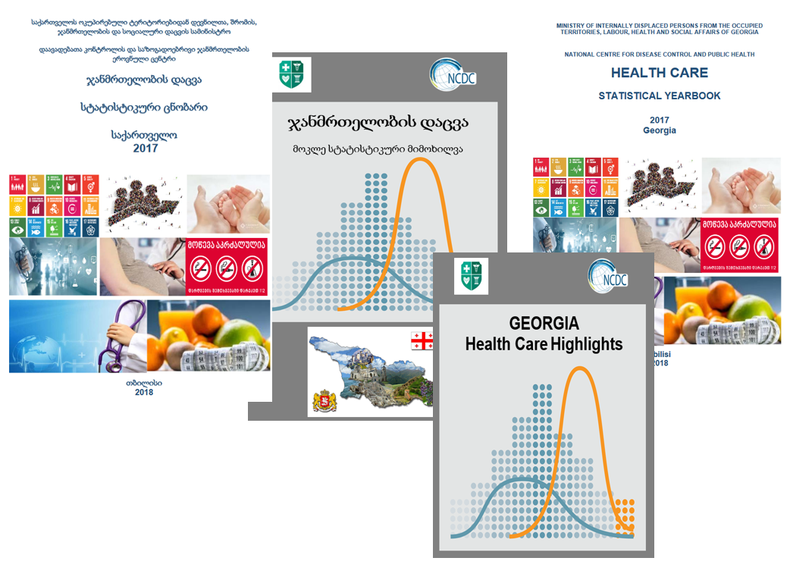

6.2. Development of the digital mobile platform:

### A technical and coordination group was established in the NCDC in order to introduce an Immunization Electronic Module. Within the scope of this work, issues, directly related to data registration and data quality improvement, were solved. Also, steps toward management of the immunization process supplies, using the electronic module, have been taken. This is essential from the point of view of the monitoring of vaccines and for the future planning;

* Existing reporting formats (066 and 025) were transferred into a new electronic platform. A digitalization process of all statistical reports has been prepared in a parallel way;
* Different activities on modification of the Electronic Module of Hepatitis C screening were carried out to decentralize the elimination of Hepatitis C in the country;
* Hepatitis C analytical system was updated;
* In the frame of Hepatitis C elimination, the NCDC carried out different campanies to deliver short messages to the population. In 2018, more than 3 million SMS were sent;
* The AIDS prevention e-System within the Global Fund funding became operational in a real-time;
* The Center’s newly designed web-site became operational added by intranet function;
* The instensified works were conducted to create new and updated e-Systems Different activities in the field of electronic systems development and updating were carried out:
  + Blood Donor System;
  + Registration process of chemicals.

**Major Challenges**

* Data Quality (Coverage, accuracy, timeliness)
* Human resources development
* Development of the system and transfer from paper-based to electronic reporting

STRATEGIC PRIORITY 7:

PROMOTE DEVELOPMENT OF PUBLIC HEALTH SYSTEM MANAGEMENT

Key Achievements

* The National Center for Disease Control and Public Health was re-certified ISO 9001:2012 (SAI-Global Georgia). The audits were conducted at the central administrative, financial-economic departments as well as at the Adjara and Imereti Divions
* Imereti Divison purchased a bacteriological food filling machine and designed a food filling machine in laboratory facilities in compliance with relevant standards
* The PHC epidemiologists were trained the Field Epidemiology Frontline Course

7.1 Supporting the establishment of modern structure, sustainability and effective management of the system

Department of Public Health Regional Management of NCDC provided coordination of the activities of regional representatives and municipal public health centers, conducted targeted trainings and mentoring, coordinated collaboration with local self-government authorities, other infrastructural units of the system and international partner organizations as well as monitoring of state programs implementation at municipal public health centers was conducted by NCDC regional divisions. Among them some of the implemented activities are:

* The field epidemiology basic course (FRONTLINE) was conducted for municipal public health specialists under the auspices of CDC;
* A pilot project titled “Integration of Tuberculosis, HIV and Hepatitis C in Primary Health Care and Building Partnership for Disease Early Detection in the Region of Samegrelo-Zemo Svaneti” has been introduced since April 2018. The municipal public health centers of Zugdidi, Abasha, Martvili, Senaki, Khobi, Tsalenjikha, Chkhorotsku, Mestia and public health center of self-government town Poti have been involved in the project as well as medical institutions and rural ambulatory doctors and nurses. The project was implemented with the financial support of Global Fund, Hepatitis C Management State Program, and local self-government authorities;
* Since October 2018, in frames of the Hepatitis C Management State Program, a project called „The Public Space in Hepatitis C Elimination Service“ has been launched in 12 branches of Public Service Halls, within which screening studies have been conducted;
* A program for hepatitis C micro-elimination and a massive screening of the population have been implemented at regional towns and villages;
* 2 meetings were conducted by DTRA support in terms of Georgian-Azerbaijan transboundary relations;
* The training course titled "Practical Aspects of Sample Collection from Patients with Suspected Infection of Especially Dangerous Pathogens, their Registration and Management of Transportation” was conducted with the support of DTRA.
* Rehabilitation-reconstruction works of the immunization warehouse office were performed in Imereti Division of the Center. Additionally, 30 square meter warehouse has been arranged in order to ensure continuous supply of medical facilities of Western Georgia with Hepatitis C test systems and consumables;
* Informational materials with the brief descriptions ("profile") of all municipalities and respective public health centers were prepared and published.

7.2 Provision of the population with timely and comprehensive information on health risks and preventive interventions, implementation of modern methods of feedback

To raise efficiency of public heath interventions the following important activities were implemented in 2018:

* Communication and informational meetings with the heads of vaccination offices were conducted regarding immunization issues;
* Meetings with kindergarten directors and school principals were held to improve Measles and HPV vaccination coverage index;
* In the frames of the Immunization week, the joint events were held by Public Health Regional Management Department divisions and municipal public health centers, in which the children policlinics, educational resource-centers and preschool educational institutions took part.
* Informational meetings were conducted regarding tobacco control legislation and monitoring with the public health centers as well as with managers of hotels, café-bars and restaurants and other mass societies.

7.3 Facilitate improvement of the legislative basis for the functioning of public health care units

The Center’s specialists in collaboration with representatives of the municipal public health centers conduct regular discussions on the matters of amendments of the existing legislative base, which will promote further strengthening of public health sector.

7.4 Development and strengthening of the public health laboratory network

* The recurring recertification of laboratory quality control - ISO 9 001 was performed at Imereti and Ajara regional divisions of NCDC;
* Introduction of Laboratory Information Management System (LIMS) was launched at regional laboratories;
* Representatives of regional laboratories took part in the workshops of the national microbiology laboratory network which was dedicated to the launching of the implementation of antimicrobial national strategy as well as CAESAR and EUCAST standards;
* Regular upgrading of professional qualification of laboratory specialists was going on with the support of DTRA;
* According to the laboratory international standards requirements, clinical bacteriological laboratory enrolment in the external and internal quality control system is continuing;
* Implementation of EUCAST standards at the laboratories of the Public Health Regional Management Department is under way.

**Major Challenges**

* Drawbacks in management and coordination of municipal public health system
* Lack and poor funding of municipal programs driven by local necessities
* Non-regular updating of office and material-technical bases, transportation vehicles and non-optimal staff schedules
* Lack of qualified personnel, difficulties in their attracting and retaining due to the low motivation, deficiency of reserve
* Lack of mutual accountability between regional structures and municipal public health centers.

OTHER ACTIVITIES IMPLEMENTED FOR THE DEVELOPMENT OF PUBLIC HEALTH SYSTEM AND NCDC

Partnership

One of the significant priorities of the Center is the collaboration with the local and international government, non-government and private organizations.

For the first time Georgia was elected to chair the Standing Committee of the WHO Regional Committee of Europe (2017-2018), represented by the NCDC Director General. Over the year three sessions of the Committee were chaired by Georgia.

On September 17-20, 2018, 68th session of the WHO Regional Committee for Europe was held in Rome (Italy). For the first time a representative of Georgia, NCDC Director General was elected as an executive president of the 68th session.

In 2018 the NCDC Deputy Director in Research was elected by WHO as a member of Joint Coordinating Board of the Special Programme for Research and Training in Tropical Diseases (JCB) for 4 years (2019-2022) term.

It was established the interagency Board of Governors representing: LEPL L. Sakvarelidze National Center for Disease Control and Public Health, LEPL Laboratory of the Ministry of Agriculture and the LEPL National Food Agency with the goal to develop triple cooperation for improvement of unified communicable disease lab surveillance systems; to standardize Biosafety and Biosecurity; Public Health Threats and Emergency Preparedness for development of scientific diplomacy; for expansion of cross-border collaboration; continiuous professional development.

As a result of NCDC intercession with European Commission for TAIEX assistance, an Expert Mission in Blood Safety was held in 18-20 June in Georgia.

It was elaborated and reconciled the mentorship training plan for the regional public health and laboratory network specialists which will promote the continuous professional development of the Center (educational component). The mentorship trainings are financially supported by the DTRA.

In 15-19 October, 2018, in the frame of the Norwegian Agency for International Cooperation and Quality Enhancement in Higher Education (DIKU) financed project: Georgian-Norwegian cooperation in Public Health and participation of the Arctic University of Norway (UiT), NCDC and Georgian universities, training course was held for master and PhD students in “Global and International Health”.

In 25-26, 2018 in Astana, Kazakhstan the Global Conference was held “from Alma-Ata Towards Universal Health Coverage and Sustainable Development Goals”, organized by WHO, UNICEF and the Government of Kazakhstan. The milestone of the conference was endorsement of Astana Declaration on Primary Healthcare, signing of which was attended by the NCDC representative.

In October 26, 2018, NCDC held the meeting with the representatives of international organizations. The aim of the meeting was to present the recent institutional strengthening of the NCDC, to introduce the new Strategic Plan of the Center for 2018-2022 and to discuss the ways of future collaboration.

On November 4-7, 2018, IANPHI (NCDC is a member of IANPHI) annual meeting was hosted by the Public Health England. Special attention was paid to the prevention of diseases and perspectives of future development of public health.

In 27-28 November, 2018, the NCDC representative took part in the Third Coalition of Partners Expert Meeting on Strengthening Public Health Capacities and Services in the European Region (CoP). Meeting was held in Ljubljana, Slovenia and organized by European Public Health Association (EUPHA), WHO/Europe’s public health services programme and WHO and Slovenia’s Ministry of Health.

In 10-14 December 2018, for the first time in Georgia it was held the international workshop “Winter School on Global Health: Strengthening Academic Capacities in Global Health in Georgia”, organized by the Institute of Global Health and the National Center for Disease Control and Public Health in cooperation with the University of Copenhagen and Maastricht University, the aim of which was Scaling-up academic activities in Global Health. The workshop received a positive evaluation and it was planned to expand the initiative in the future.

On December 17, 2018 the US Walter Reed Army Institute of Research (WRAIR) in cooperation with the NCDC marked the 125 anniversary of establishment of WRAIR. The ceremony was held at the NCDC and attended by the WRAIR’s lead persons and Embassy Charge D'Affairs as well as the respresentaitves of the collaborative organizations and universities.

In 2018 Director General of the Center participated in a number of important international events. Among them, High Level Meeting on “Health Systems for Prosperity and Solidarity", held in Tallinn on June 13-14, 2018 and the IVHEM meeting related to the elimination of Viral Hepatitis, held in Amsterdam on December 2-8, 2018, etc. should be mentioned.

In May 2019 the NCDC hosted a high-level visit of the US CDC Director – Dr. Robert Redfield. Dr. Redfield underlined the achievements of Georgia during the meetings with the Government authorities for what he expressed his gratitude to the Georgian partners.

A few important publications were elaborated for the Center’s visibility: NCDC Organizer for 2019, providing important information on health issues, including revised information about international partnership; “Key Achievements and Challenges for 2013-2018”; Booklet on a “Role of the US Donor and Partner Organizations in the Development and Strengthening of Public Health, Biomedical and Biotechnological Potentionial in Georgia”; “WHO and Georgia: Quarter Century of Cooperation” etc.

Public Relations/Communication

Public information was delivered on the regular basis by the National Center for Disease Control and Public Health based on the agreement with the Ministry of Internally Displaced Persons from the Occupied Territories, Labour, Health and Social Affairs of Georgia. TV, radio, news agencies, print media, internet portals, etc. are actively involved in this process. After airing the processed materials are posted on the Center’s website (www.ncdc.ge), Facebook and other social networks (youtube, myvideo, twitter); Press releases for news agencies and journalists, as well as photo and video materials are developed for each meeting, press conference, briefing, conference and other events.

Administrative activities

* Complete relocation to the new administrative building of the Center (Kakheti Highway # 99 Tbilisi) and related technical and organizational measures were successfully implemented
* The NCDC Supervisory Board Meeting was held in a new administrative building
* Center’s new Strategic Plan 2018-2022 was approved
* Center’s "Hot Line” (number 116 001) activities and reporting system was improved.

Human Resources Development

Over the year of 2018 strengthening and development of Human Resources were implemented. The Center has been actively and successfully implementing the state program „Rules and conditions of Internship in Public Institutions“. In 2018, 85 interns were trained, including 21 students within the state program. In order to improve their qualification, 4 participants underwent traineeships and 5 participants - professional practice program.

The Center implements the gender equality policy, which creates equal working environment for women and men. During 2018, the distribution of the employees by gender-based principle was as follows: female - 330, male - 130.

Legal activities

* 13 grant project documentation were developed and submitted for the Government’s approval in compliance with the Ordinance #126 of 14 March 2011 of the Government of Georgia “On Measures to be Taken Related to Grants by Appropriate Institutions of the Executive Authority and by State Controlled Legal Entities of Public Law”
* 10 draft ordinances of different content of the Government of Georgia were developed and submitted for approval to the Government
* 3 draft resolutions of the Government of Georgia on the issues under the center’s competence was developed and submitted for approval to the Government
* 5 draft orders of the Minister of Internally Displaced Persons from the Occupied Territories, Labour, Health and the Social Affairs were elaborated
* 43 letters related to registration were elaborated and submitted to the Ministry of Internally Displaced persons from the Occupied Territories, Labour, Health and the Social Affairs of Georgia and LEPL State Regulation Agency for Medical Activities
* 8 memoranda with the partner organizations were signed
* In 2018 NCDC received 181 applications for issuing public information, out of which 180 were satisfied, 1 application was not satisfied (Required information was not available, since the issue was not within the Center’s competence).

Financial Sustainability

Consolidated budget performace for 2018: Performance of consolidated budget of the NCDC amounted to 72, 9 million GEL of expenses, out of which 48% is allocated on Public Health State Programs, 27% on Global Fund Programs, 14% on Disease Control and Epidemiological Safety Management Program(centralized), 10% on Grant projects - financed by donor organizations and 1% of the Center’s commercial incomes

Funding by Donor Organizations for 2018: In 2018 the amount granted by donor organizations equaled to 23 761 thousands USD. It is noteworthy the funding by the Global Fund which amounted 15 721 thousands Gel oout of which the direct payment – 1 847 thousands Gel

In 2018 the NCDC managed 62 grant projects sponsored by 20 donor organizations. The total amount equaled to 26 944 thousands Gel (including Global Fund - 19 345 thousands GEL, other – 7 599 thousands GEL).

Commercial activities: In the framework of commercial activities the cash revenues amounted to 797, 6 thousands GEL which increased by 8.5 % in comparison with 2017; it is also notable that the incomes had been increased to 66% in comparison with previous year.

Procurement sustainability: Center’s total procurement plan amounted to GEL 70.6 million, broken down into major categories:

* State Budget - 39,3 million Gel;
* Global Fund - 29,1 million Gel;
* Commercial activities - 3,0 million Gel;
* Donor organizations - 1,8 million Gel.

In comparison with 2017 the procurement plan is relatively increased within the inner incomes. 172 tenders (75%) have been successfully completed and the tender commission has signed the agreements with revelead winner applicants. The lack of signed agreements in 2018 was caused by the identical procured objects and consolidated tenders of state programs. In addition, a multi-year contract signed in the previous year, which need not be performed in 2018.

Based on the amendments to the Law on Public Procurement in 2015, 149 contracts were signed in 2018. It is noteworthy that in 2018, the Center made only one emergency purchase.

Accounting status: At the end of 2018, the total value of assets owned and used by the Center amounted to 247,107 thousands Gel. 14,250 thousand Gel was received as a non-financial asset in 2018 (government procurement 2 156 thousand Gel and free of charge – 12,094 thousand Gel).

In 2018, the lender's debt decreased by GEL 16,000 compared to the previous year. Debit was increased by 10 584 thousand GEL in 2018 compared to the previous year, due to the Center’s Immunization Program's for the purchase of vaccines and consumables.

Logistics

In the new location of the National Center for Disease Control and Public Health (Kakheti Highway # 99), a total of 76 units (four shelves) were installed in the warehouse and 10 units of three-level pallet shelves were installed, as well as 12 small refrigerators, where the temperature is recorded twice daily (morning and evening). ) Supplies from the warehouses of Asatiani str. # 9 and Kiziki Street were relocated and stored in the new warehouse, as well as laboratory equipment and spare parts separately. The stock information is fully reflected in the electronic stock management module as of January 1, 2018, and therefore, commodity turnover operations are conducted centrally and regionally within the system.

In 2018, medical supplies at total of 4,756,933 Gel were received, out of which 2,783,448 Gel were consumed by the state program fields, 266,122 Gel under grant projects, 753,756 Gel under humanitarian status, and 54,718 Gel were purchased through commercial activities. The goods at value of 898,889 Gel are purched through Disease Control and Epidemiological Safety Management Program which are fully housed and reflected in the electronic control module.

In 2018, 1,478 invoices (valued at 6,830,556.93 Gel) were issued, out of which 301 (876,072.65Gel) were issued within the framework of the Disease Control and Epidemiological Safety Management Program, 83 (94,007 Gel) issued through commercial activities, 321 - free of charge (worth of 1,572,286 Gel), 648 (3,288,795 Gel) - under state programs and 125 (999,395 Gel) were issued within the grant projects.

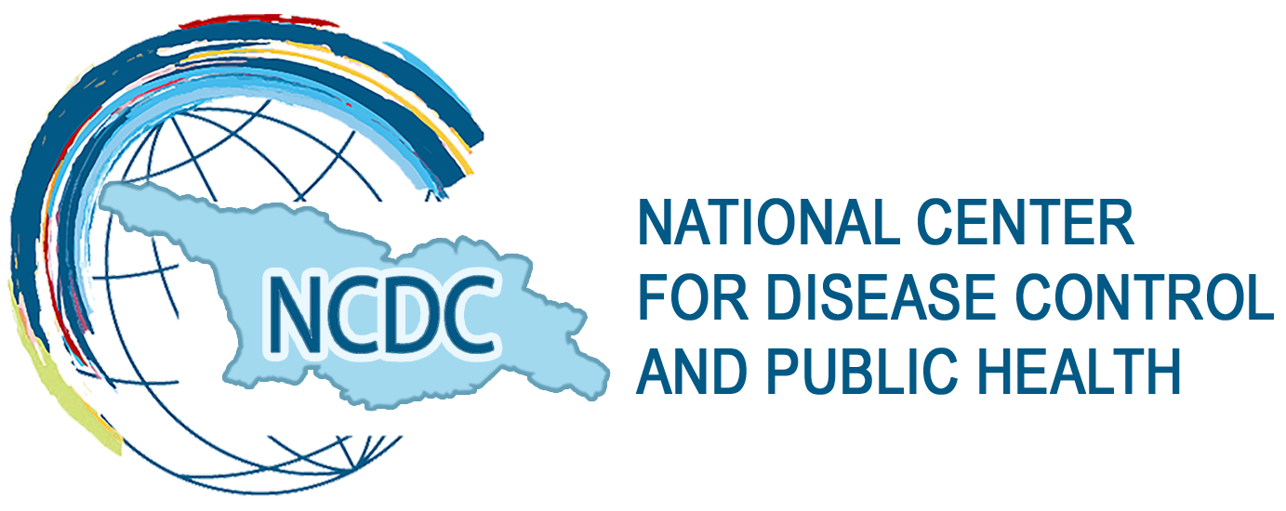

Add: Kakheti Hwy #99

Tbilisi, 0198, Georgia

Telephone: 116 001

E-mail: ncdc@ncdc.ge

www.ncdc.ge

www.fb.com/ncdcgeorgia

www.twitter.com/NCDCGeorgia