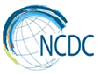

Levan Sakvarelidze National Center for Disease
Control and Public Health

Key Achievements and Challenges

2013-2017

Tbilisi
2018

Address of the Director General of the National Center for Disease Control and Public Health

Dear Friends,
Health is a primary human right and one of the major driving forces for the development of the countries. Levan Sakvarelidze National Center for Disease Control and Public Health (NCDC) is designated as a central agency for public health in Georgia. Early detection and prevention of diseases is NCDC’s core mandate. The Center has significant role in development of country's health care system and improvement of public health.  A precondition of implementation of the Center’s major objectives is strong infrastructure, modern laboratories, and most significantly, highly trained human resources. This allows NCDC to implement properly and in timely manner prevention of communicable and non-communicable diseases, monitoring, reduction of harm caused by environmental and other behavioral risk factors on the basis of evidence-based information through public health preparedness and timely response to threats. | 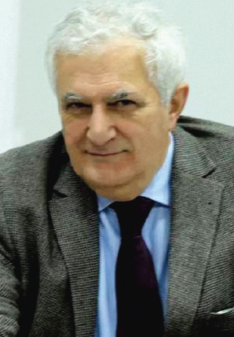
The five-year cycle of development defined by the Center's Strategy (2013-2017) completed in 2018. The document presents a brief overview of the main achievements and challenges for this period, based on the Center’s annual reports. Certainly, the present document does not fully reflect all achievements and challenges of NCDC, but it provides all major milestones of the recent five years.
I would like to thank each employee of the Center for their contribution and dedicated work and hope that we will continue to implement innovations and public health initiatives in order to act more efficiently with “Our knowledge - for public health”, that will facilitate the Movement for healthy Georgia.
With best regards,

Amiran Gamkrelidze, MD, PhD, Professor
Director General

Decrease of Morbidity, Disability and Mortality Caused by Communicable Diseases

Immunization

- The population knowledge, attitudes and practices (KAP) survey has been conducted, and the National Immunization Communication Strategy 2017-2021 was developed based on the findings
- HPV vaccine introduction communication plan (2017-2019) and Measles, Rubella and congenital rubella syndrome elimination national action plan have been developed
- Four new vaccines were introduced to the national immunization schedule (Rotavirus, Pneumococcal, Inactivated Poliomyelitis (Hexa) and oral poliomyelitis (bivalent) vaccines)
- Vaccination of girls born in 2008-2009 against human papilloma virus was introduced in Tbilisi, Kutaisi and autonomous republics of Achara and Apkhazia
- As a preparedness measures for the flu season, risk groups are annually vaccinated and coverage being expanded; sentinel surveillance of the flu-like diseases is maintained in the country with continuous monitoring
- Zero reporting of rabies cases have been sustained for three consecutive years, for the first time since 1980, ensured by the uninterrupted supply of rabies vaccines and serums (immunoglobulin)

Number of Rabies cases, Georgia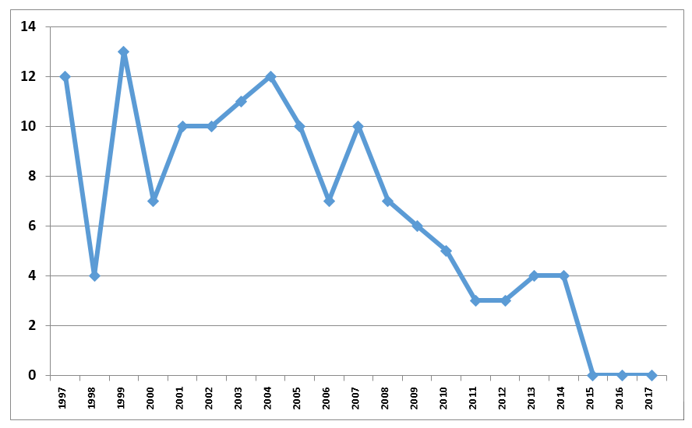

- Supportive supervision visits to the healthcare facilities are carried out regularly to promote the poliomyelitis and measles/rubella eradication programs and improve the vaccination coverage
- For the first time, around 30% of the cold chain infrastructure was upgraded with state support
- The knowledge, attitudes and practices survey were conducted among the healthcare personnel and elder population on measles and rubella vaccination
- The European Immunization week is marked annually on the last week of April
- The Immunization in practice trainings are conducted for the primary healthcare providers and epidemiologists for every mulicipality
- Mobile and web application for parents on vaccination was developed
- The immunization management module was updated
- The nationwide immunization coverage survey was conducted
- The coverage trends for all antigens is increasing, but the national target of 95% is still to be achieved

Coverage trends with the major antigens, Georgia, 2013-2017

Communicable Diseases Surveillance

- In order to deter communicable diseases in the country, the following documents were approved: Ebola Response Plan; Rule of functioning of Electronic Integrated Disease Surveillance System for managing infectious diseases and for those which are caused by EDPs; Action Plan for managing and prevention of Crimean-Congo Hemorrhagic Fever outbreak; Multisectoral measures to be taken for prevention of Rabies in 2014-2018; Hepatitis C National Elimination Strategy 2016-2020; Tuberculosis and HIV strategy; National Strategy of Antimicrobial Resistance; Zika Virus Surveillance System (During the period of mosquitoes spread, vast territories were processed by disinfectants)
- The regular monitoring of implementation of National Hepatitis C Elimination Strategy 2016-2020 was being conducted; Georgia was granted a „NOhep Visionary“ status of European Region on a World Hepatitis Summit in Sao Paulo, on November 1, 2017; “C hepatitis Screening” - state standard (protocol) for management of clinical condition was approved; Electronic module of hepatitis C screening was developed and implemented

- Hepatitis C population-based seroprevalence survey was conducted in Georgia in 2015

HCV RNM+ - prevalence and quantity in regions and cities
(Data of 2015 Hepatitis C population-based seroprevalence survey)

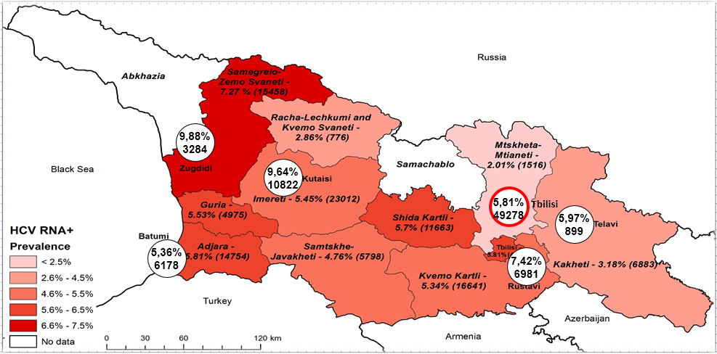

- Elimination of Mother-to-child Transmission of HIV and Congenital Syphilis Strategy and Action Plan were developed; Case-based reporting was established on pregnant women and congenital syphilis
- Georgia maintains polio and local malaria free status (there were no malaria cases detected in Georgia since 2013)
- Helminth therapy and prophylactic deheminthisation of children aged 5-9 years has started. After introduction of rotaviral vaccination, in children aged < 5 years, the diarrheas due to rotavirus have decreased

Incidence of malaria per 100000 population

- Sentinel surveillance was established upon AMR of N. gonorrhoeae; AMR Point prevalence survey was conducted for the first time in 5 healthcare facilities in Tbilisi and 1 healthcare facility in Rustavi
- In order to deter local transmission of rubella and measles, permanent immunization measures are being taken
Incidence of Measles per 100000 population
- Decrease of incidence of Crimean Congo Hemorrhagic Fever has started from 2014

Crimean-Congo Hemorrhagic Fever, Incidence per 100000 population, Georgia

- In several regions residential and non-residential areas are being processed seasonally by insecticide (Solpac)
- New Tularemia focus was identified in Imereti Region
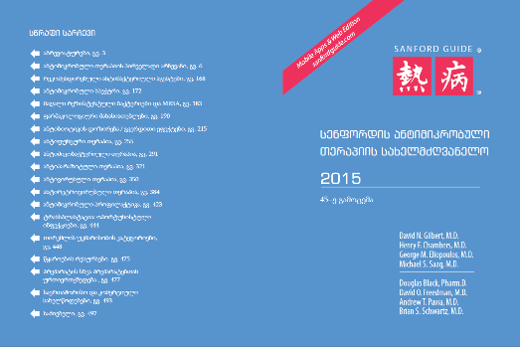
- Specialists of Public Health Centers throughout the country were retrained in compliance with new requirements for surveillance of tuberculosis
- Joint project of National Center for Disease Control and Public Health and the Bundeswehr Institute of Microbiology on surveillance of communicable diseases is being implemented, within the scope of which, for the first time the research of the spread of the tick-borne encephalitis virus by specific molecular and serologic markers was performed in different environmental and clinical specimens
- The Sanford Guide to Antimicrobial Therapy was translated and published into Georgian

Public Health Preparedness and Response

- National Center for Disease Control and Public Health is designated as an IHR National Focal Point and is a National coordinator of GHSA  - Georgia – leading Real-Time Surveillance action package, contributing to Zoonotic Disease Action Package and National Laboratory Action Package within GHSA  - Updated Epidemic, Pandemic and Biological Incident Response Plan as well as development of disease specific plans | 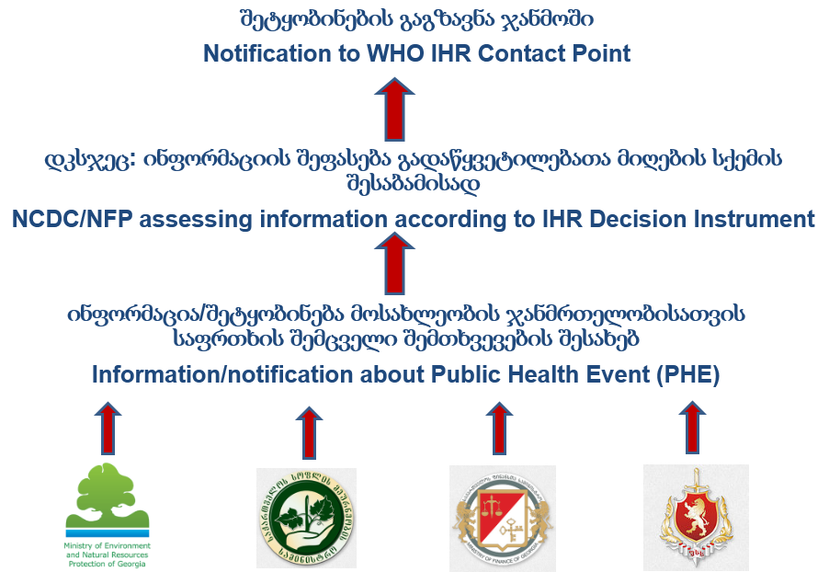
- Taking part in GHSA ministerial and high-level meetings, chairing Real-Time Surveillance bilateral meeting;
- “Accelerating Progress in Real-Time Surveillance Action Package of GHSA”, meeting conducted in Georgia within One Health Approach
- Timely exchange of notification with WHO and various countries regarding the spread of potential infectious source or travelers under the risk of being infected with communicable diseases
- Annual monitoring of IHR (2005) Core Capacities
- Taking part in WHO project: „Voices of the Region” regarding the successful implementation of IHR in Georgia

Lugar Center Capacities
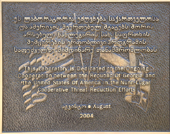 | R. Lugar Center for Public Health Research became the part of the National Center for Disease Control and Public Health since May 2013. The BSL-3 facility is unique not only in Georgia but the entire Caucasus and Central Asia Region and represents the referral laboratory of public health system of Georgia.
- On June 5, 2014 “Agreement between the government of the United States of America and the government of Georgia concerning the transition of sustainment cost and responsibilities over the unified laboratory system for detection, epidemiological surveillance and response to especially dangerous pathogens, and the Richard G. Lugar Center for Public Health Research in Georgia” was signed
- In 2015 NCDC received international certification ISO9001:2008 in management
- Laboratories of General Bacteriology and Serology of Richard Lugar Public Health Research Center successfully passed through the assessment and received international accreditation ISO15189 from ANAB/ANSI
- Three WHO accredited virological laboratories (Polio, influenza, Measels-Rubella) have been re-accreditted

First time in the World:  - New species of Orthopox virus was discovered (so called Akhmeta virus)  - Brucellosis and leptospirosis pathogens were found in bats  - Bartonella taylorii was detected as a human pathogen in patients with HIV / AIDS  - Janibacter hoylei PVAS-1 was separated from endocarditis clinical sample  First time in Georgia: |  | 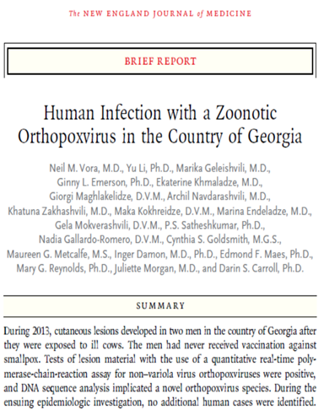
- The first case of Cowpox was confirmed in Samegrelo region
- 41% of suspected but unconfirmed samples of Anthrax were proved to be caused by the viral infection of Parapox
- Information on AMR was processed and published in the CAESAR Annual Report
- Gram-negative bacteria were detected as high resistant (ESBL)
- For the first time bacterial isolates of carbapenem for monitoring was introduced
- The mechanism of resistance was developed and resistant strains of Neisseria gonorrhea were revealed (multiresistant, fluoroquinolones)
- Viral pneumonia cases, bacterial research/molecular method found to be positive for bacterial etiology on Streptococcus pneumonia
- Anthrax in soil active foci detection increased to 15% (10% historically). Correspondently, increased the risk of disease in animals, as well as in humans
- Tularemia new focus was detected in Kvemo Kartli region
- Cl. dificille was isolated from clinical samples for the first time in Georgia
- Leptospirosis species were identified in the country
- Escherichia coli (STEC) toxical markers (stx1/stx2/eae/Ehly) were identified
- Salmonella spp., Shigellosis spp. And inner toxins were identified producing Escherichia coli (STEC) of the genetic profiles of the pulsing field gel electrophoresis (PFGE), which is the source of an outbreak detection and identification
- Sequencing of measles / rubella was introduced. Cases revealed measles genotype - D8
- New serotypes of Salmonella and Shigella have been found
- Through GARP (Genetic Algorithm for Rule-set Production) it became possible to forecast and ecologically model of vectors; GIS database started to be developed
- Identification of mosquito species spread on territory of Georgia with new sequence-based molecular mothodology – DNA barcoding was performed. 50 sequences were uploaded into international database BOLD Systems
- The genomic sequences of Y. pestis, B. anthracis and Brucella strains were uploaded into NCBI database

Decrease of Morbidity, Disability and Mortality caused by Non-Communicable Diseases

Non-Communicable Diseases Surveillance
- Strategy and Action plan 2017-2020 for Non-Communicable Diseases has been approved; National Cancer Control Strategy has been revised and Action Plan 2017-2020 has been developed; National Inter-sectorial Coordination Counsel for Non-Communicable Diseases Prevention and Control was established and National Oncology Board was approved
- State Health Promotion Program became operational
- Two Perinatal Health Reports have been developed
- Active surveillance of death cases of reproductive age women and children under 5 has improved
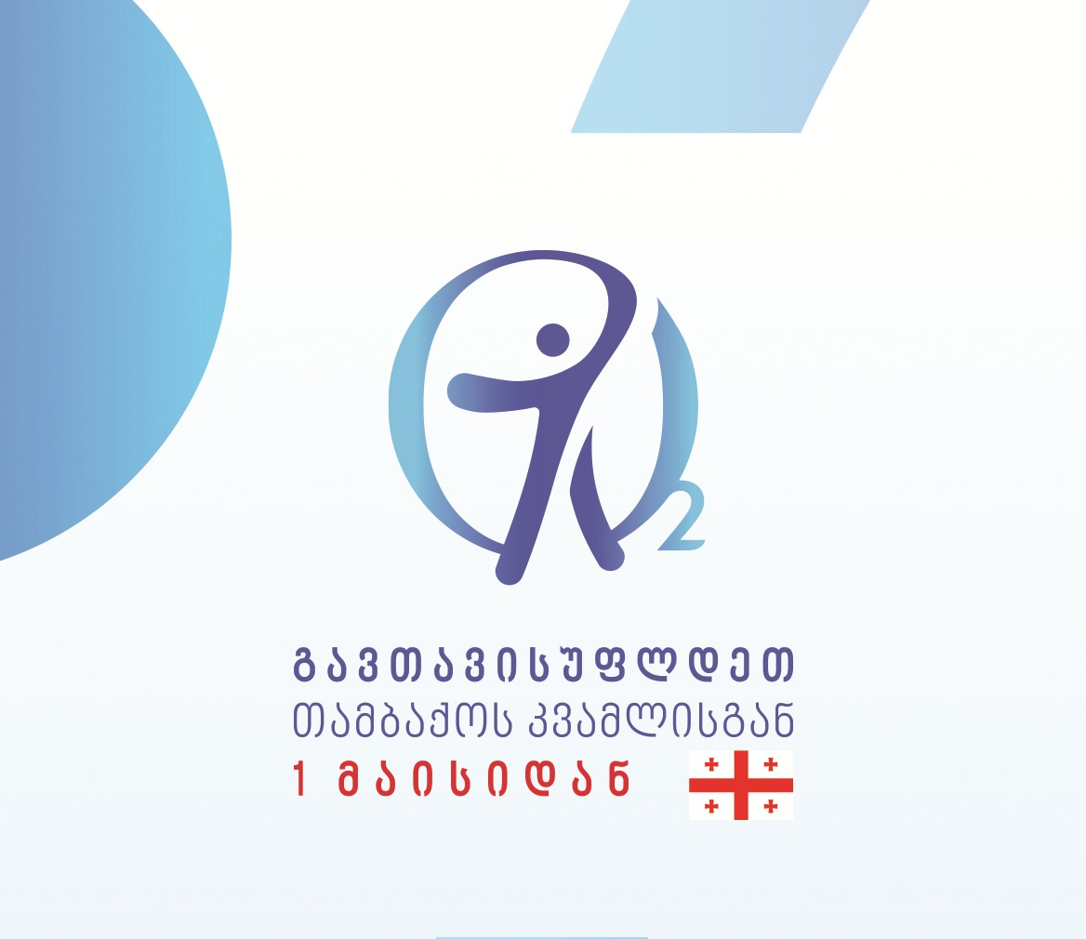
- Tobacco group was created. Tobacco control regulations have been strengthened, new legislative changes are developed and implemented; Activities is being carried out for the implementation of main directions of national action plan for tobacco control; Tobacco Quit-line is available for 7 days a week
- Georgia has been selected as “FCTC 2030 Partner Country” for WHO Framework Convention on Tobacco Control among 15 countries throughout the world (the only country from the European region). The Project “Supporting Implementation and Enforcement of Changes in Tobacco Control Law in Georgia with the goal to reduce demand on tobacco” is being implemented
- “Quit smoking” Mobile App has been developed
- Primary health care doctors have been retrained on short consultation and treatment of tobacco dependence
- STEPs survey has been conducted for the second time to assess prevalence of non-communicable diseases behavioral and biological risk-factors
- Global Youth Tobacco Survey (GYTS) has been conducted for the third time in Georgia
- Reproductive Age Mortality Survey has been conducted (RAMOS)
- The European School Survey Project on Alcohol, Tobacco and Other Drugs (ESPAD) has been conducted;
- Survey of Iodine status among Georgian population has been conducted, which proved effectiveness of universal iodination program and reducing iodine deficiency
- Project “Strengthening Surveillance of Micronutrient Deficiency” is in the process of implementation – sentinel based surveillance is implemented
- Project “Evaluation of Knowledge, Attitude and Practice for Prevention and Control of Non-communicable Diseases at Primary healthcare level in Tbilisi and Kakheti” has been conducted
- Survey on Childhood Obesity Surveilance Initiative (COSI) has been implemented
- A qualitative research on the issues of early marriage has been carried out
- Repeated survey has been conducted in children with high level of lead in the blood according to 2015 survey results
- Facebook pages on prevention of tobacco consumption, I am donor, physical activity, healthy diet, alcohol, hepatitis C were created and operates successfully

Assessment and Correction of Environmental Hazards and Behavioral Risk-factors for Improvement of Health in Population
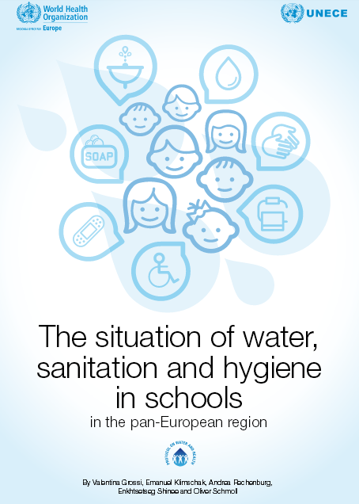
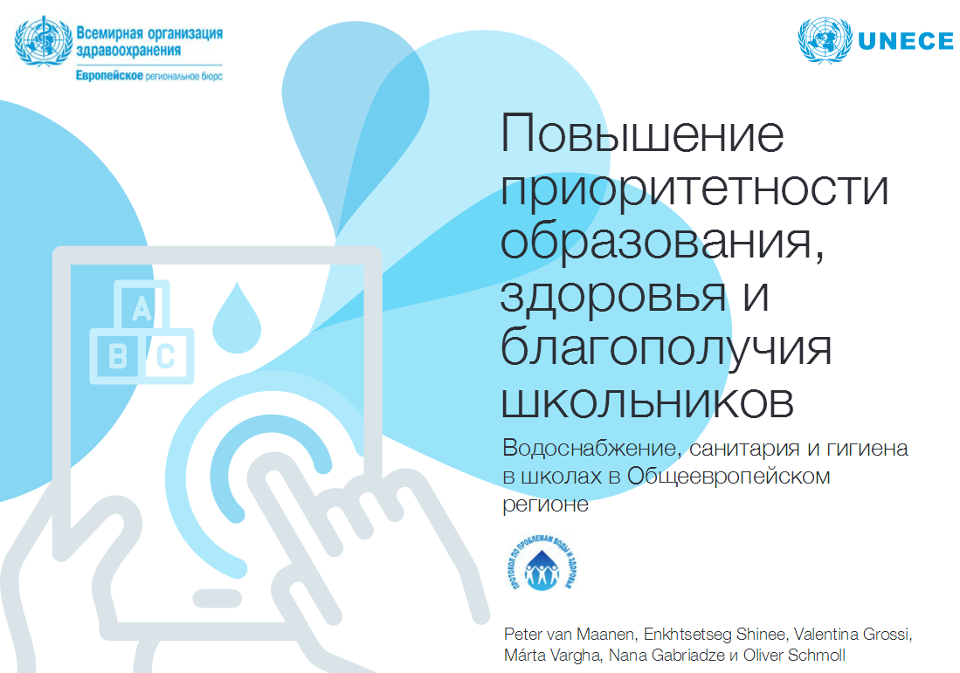
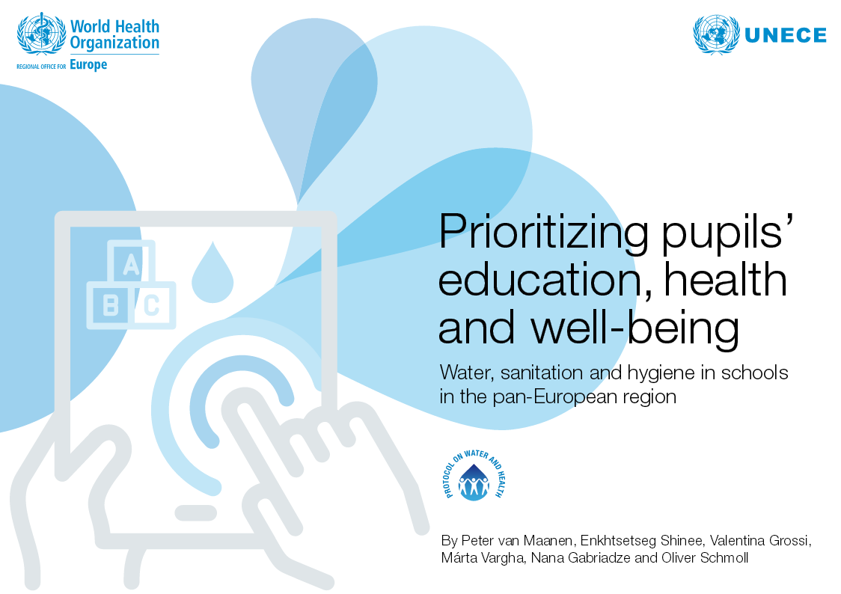
- The Visit of EU expert mission within the EU Technical Assistance and Information Exchange Mechanism (TAIEX) was carried out to "Improve medical waste management in Georgia"
- Activities on Twinning project "Enhancing Environment and Health System in Georgia" was initiated with the EU technical and financial support
- The National Environmental and National Action Plan (NEHAP) project was prepared

- The first Georgian Registry on hazardous chemical substances was created and Georgian version of chemical safety term definitions was published
- Three publications were issued in cooperation with WHO
- Environmental Health Management Working Team was established

Potential of Applied and Fundamental Bio-medical and Bio-technological Scientific Research

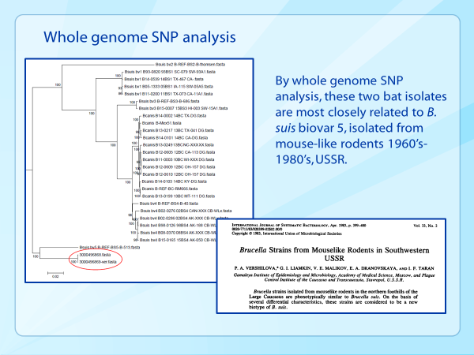
- Activities for implementation of GHOST technology for improved surveillance on Hep C
- Installation of Magpix, Luminex equipment and introduction of CCHF/Hanta detection assay
- Successful application of microagglutination (MAT) assay for Leptospira detection
- Implementation of several methods for detection of AMR genes
- Genotyping of Measles/Rubella, Rotavirus and Influenza viruses with sanger sequencing
- Upload of Georgian origin B. anthracis and Brucella genomes into NCBI database
- Sequencing of CCHF whole S segment
- Whole genome sequencing of plant pathogen Ralstonia solanacearum strains isolated in Georgia
- Active foci of anthrax in 18 villages of Kvemo kartli, 33 active foci in total were discovered new
- After study of anthrax ecology in Azerbaijan border regions increase of active foci (from 10% to 16%) in comparison with previous years was detected
- Study of seroprevalence of zoonotic diseases in animals and short time (six months) efficiency of anthrax vaccine was revealed
- For the fisrt time in Georgia clinical epidsurveillance system of Carbapenem-resistant Enterobacteriaceae (CRE) was implemented
- A phenotypic and genotypic study of on B. anthracis strains isolated from Azerbaijan border regions was conducted
- For the first time research of anthrax distribution risk factors and analysis using GARP modeling and study of activities of foci by soil types was conducted
- NCDC was granted the certificate of compliance with necessary criteria for MediPIET program training base provided by European Union
- Tularemia new focus was detected in Kvemo Kartli
- For the first time study of seroprevalence of zoonotic diseases in professional groups (veterinarians and farmers) and in domestic animals (dog, sheep, cow) was conducted
- For the first time co-infection of HIV-Bartonella was studied in Georgia
- For the first time in Georgia high resistant New Delhi Metallo (NDM) Beta Lactamase producing Klebsiella pneumonia and Acinetobacter baumannii strains were found in Ajara region. Prevalence of NDM-5 like, ST-395 type strains in Georgia was revealed
- Bartonella taylorii was detected as a human pathogen for the first time in the world
- Out of four Brucella PCR positive samples two cultures were obtained from two different species of bats. Phenotypically these two bat Brucella cultures do not match with any known species
- Over the recent five years three PhD and one MS degrees were obtained by NCDC employees. 98 scientific articles, 264 abstracts/posters, 201 different types of educational materials, 43 epidbulletins were published

Management and Coordination of Regional Public Health Divisions

- Public health national recommendations (guideline) for "Functioning of Public Health Municipal Services” were developed and approved;
- Visit of the WHO public health evaluation mission expert group was carried out in Georgia;
- Municipal programs list, its compilation and implementation methods were elaborated based on the needs of local population;
- Electronic module of logistics was implemented, which enables not only the full control on vaccine and other supplies, but also surveillance of the process;
- Bacteriological Laboratory of Imereti Division was equipped with a new BACTEC FX40 bloodculture system;
- With the active participation of public health regional divisions and sections and also with active involvement of public health municipal centers a wide-range pilot surveys were carried out: „Iodine deficiency in Georgia“, “Obesity in children”;
- Commercial laboratory research services were expanded;
- The meetings of representatives of laboratories of regional and municipal public health centers are regularly held.

Production of Medical Statistics

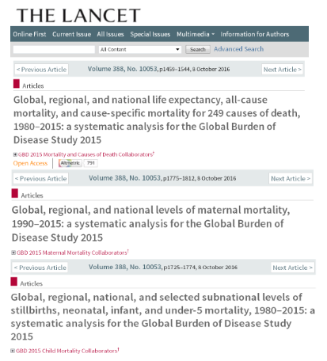
- The new case-based electronic reporting systems for hospital discharges and primary health care facilities were implemented throughout the country
- Population cancer registry has been introduced country-wide; analysis of the three-year data from the cancer registry was prepared and published
- “Pregnant women and newborn health surveillance electronic module" (so called “Birth registry’’) has been implemented throughout the country
- A medical component of birth/death registration system has been administered by the NCDC
- In the framework of the State Epidemiological Surveillance Program public health centers were participating in the verbal autopsy conducting and medical records review to improve the cause of death identification
- Statistical yearbook "Health care in Georgia“ and highlights "Health Care" were prepared and published in Georgian and English
- In 2017, two publications "Georgia Profile of Health and Well-being" and "Georgia Highlights on Health and Well-being“ were prepared for the World Health Organization, which were published by WHO Regional Office of Europe
- Nine articles were published in the journal "The Lancet" within the Memorandum of Understanding between the Institute for Health Metrics and Evaluation (IHME) at the University of Washington and NCDC

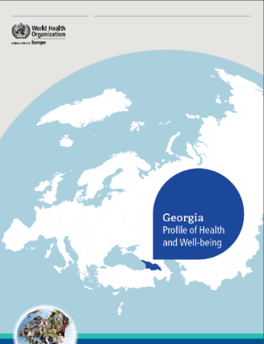
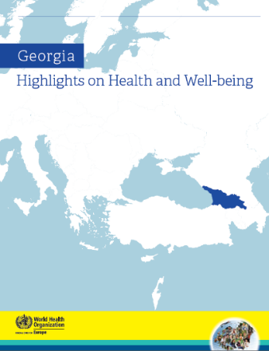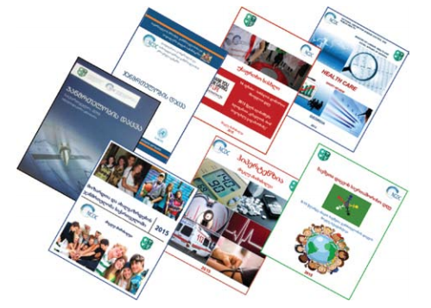

Information Technology and Its Related Issues

- One unified hot line 116 001 was applied within the center
- 3CX video conference tool was implemented
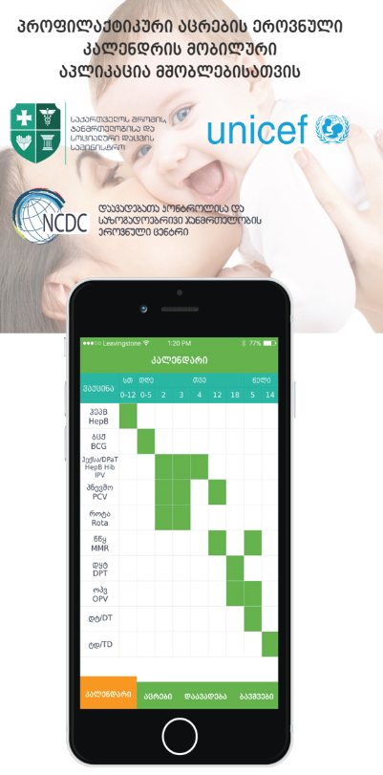
- New Email system was adapted
- User Management United System was handed over to the Center
- Classificatory module was transferred to the NCDC administration;
- Stock (logistic) module was developed and its implementation started across the country
- Multifunctional SMS engine was created and launched
- Hepatitis C screening module was developed and implemented country-wide, combining old screening data
- Test module of Laboratory Information Management System (LIMS) was created
- HIV prevention module was developed
- Blood bank database was updated
- NCDC web page was updated
- GIS licenses were updated

Major Activities of Health Care State Programs

- The State has taken over the purchasing obligation of first-line (fully) and second-line (25%) TB and AIDS medication from the Global Fund
- The vaccination of persons diagnosed with Hepatitis C by Hepatitis B and Influenza was introduced through the State Immunization Program
- The Hepatitis C screening electronic module was created and implemented, which mobilizes information on screening carried out in the previous years; the spectrum of Hepatitis C screening providers has increased; the Hepatitis C screening coverage area has increased; HIV/AIDS tandem testing along with Hepatitis C testing has been introduced
- The Unified Blood Donor Electronic Database was updated; Participation in the Unified Blood Donor Electronic Database became mandatory for all blood banks and health establishments performing blood transfusions; Focus-group survey was performed to identify motivational factors for voluntary, regular unpaid donations; financial incentive mechanisms were added to the program to stimulate voluntary donations
- 14 health establishments providing obstetrical and neonatal services were equipped with newborn hearing screening devices through state-private and international cooperation, which resulted increase of coverage area of newborn hearing primary screening; the retinopathy screening pilot in premature infants was put into operation
- A new scheme for sputum/testing material transportation was fully implemented country-wide through LTD “Georgian Post”; GeneXpert TB testing pilot project has started in 15 health institutions
- Rural doctors were provided with the necessary equipment to perform Pap tests and were given the possibility to perform the Pap test themselves and make referrals to provider clinics
- Preventive measures against vectors of transmissible diseases have started to be regularly performed in Black Sea coastal resorts (Adjara, Guria and Samegrelo regions)
- The state has taken over the commitment of Influenza sentinel base surveillance; Influenza vaccination coverage has increased
- The geographical accessibility to epilepsy diagnostic services has increased

Grant Programs supported by the Global Fund to Fight AIDS, TB and Malaria in Georgia

Since 2013 the National Center for Disease Control and Public Health has been implementing the Global Fund’s HIVand TB Programs in Georgia as a principal recipient of the grants.

Sustaining and Scaling up the Effective HIV/AIDS Prevention, Treatment and Care in Georgia

- The program provides universal access to ARVs; Coverage and geographical area for harm reduction activities has been increased; AIDS’ and Tuberculosis’ treatment electronic data bases has been strengthening and new modern approaches to the HIV prevention has been implemented
- As a result of the implemented programs the risky behaviors among men who have sex with men (MSM) and commercial sex workers (CSW) has been reduced and the HIV testing has been increased

New HIV Cases in Georgia per year

Source: http://aidscenter.ge/epidsituation_geo.html

- According to the ARV treatment adherence Georgia occupies the first place in the region. Georgia shows the best performance for the 12 month retention rates from the beginning of the ARV among adults as well as among children
- In the region the Georgian was pioneer for initiating Pre-exposure prophylaxis (PrEP) among MSM

Sustaining Universal Access to Quality Diagnosis and Treatment of all forms of TB in Georgia

- In recent seven years (2010-2016) 35,000 TB patients were identified and enrolled in effective treatment
- All presumptive for TB patients are provided with appropriate tests and diagnostic means; GeneXpert MTB/RIF is used throughout the country for rapid diagnosis of TB and resistance
- All patients suffering from tuberculosis, including people with resistant forms, are provided with high quality medications
- A new methodology of contact tracing and referral to specialized medical facilities has been introduced
- 83% of patients successfully completed TB treatment; Video Observed Treatment has been introduced; Patients are provided with monetary incentives

Notified TB cases

Quality Control

- Laboratories of General Bacteriology and Serology of Richard Lugar Public Health Research Center successfully passed through the assessment and received international accreditation ISO15189 from ANAB/ANSI, American Accreditation Body  - Implemented an ongoing External Quality Asurance (EQA) program on a monthly basis  - Implemented personnel competency assessment routine practice  - Approved and implemented Internal Audit yearly plan  - Developed, approved and implemented more than 300 quality documents (SOPs, forms, guidelines and etc.) | 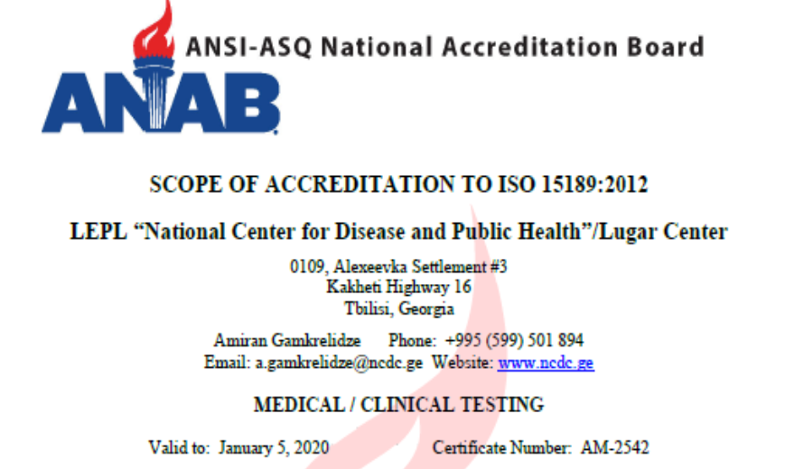
- Developed and approved Quality Manual
- Conducted simulated and real audits
- Renewed Quality Committee member’s list
- Elaborated and implemented risk prevention plan

Collaboration with the local and international organizations

- Georgia was elected to chair the Standing committee of WHO Regional Committee of Europe (SCRC) for 2017-2018  - U.S. Senator Richard G. Lugar sent a letter of appreciation to the General Director for the Center’s successful activities and scientific achievements  - In the framework of the collaboration between the NCDC and the U.S. Defense Threat Reduction Agency (DTRA) the Agreement between the Government of the United States of America and the Government of Georgia concerning the transition of sustainment costs and responsibilities over the unified laboratory system for detection, epidemiological surveillance and response to especially dangerous pathogens, and the Richard G. Lugar Center for Public Health Research in Georgia, was successfully implemented | 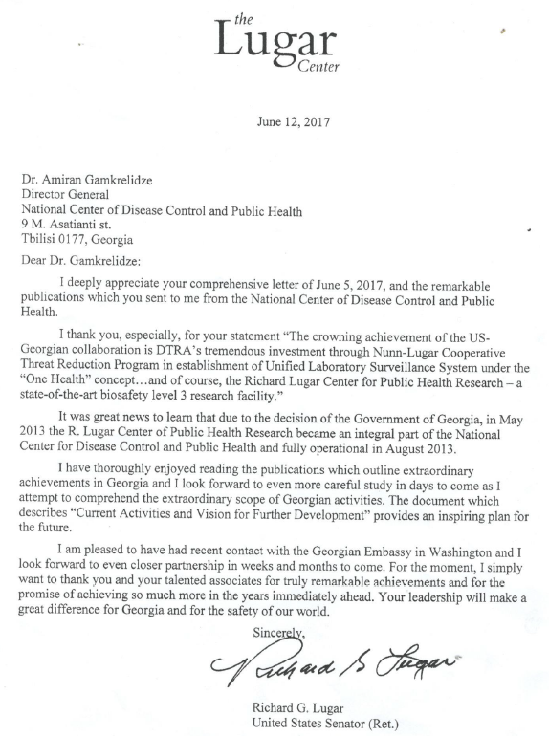
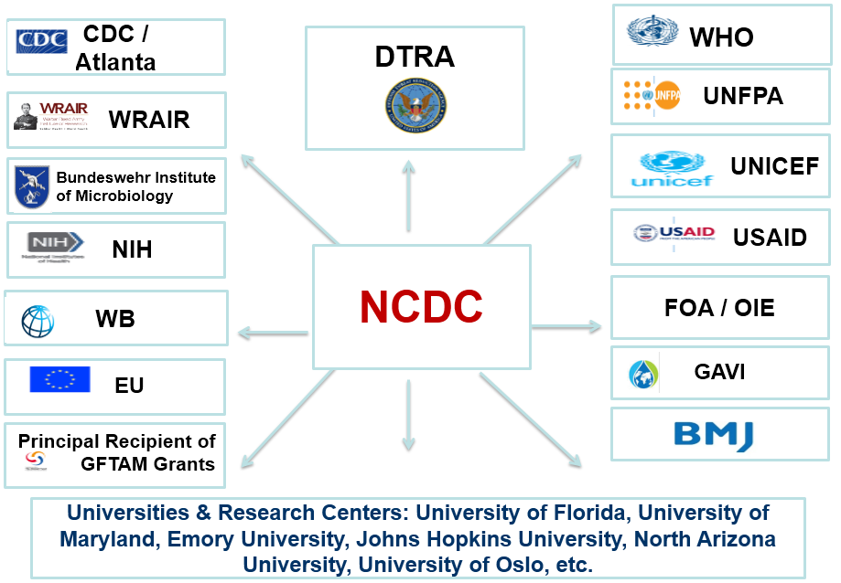

- For the first time Georgia was elected to the WHO Executive Board for 2017-2020
- For the first time the SCRC session was held in Georgia on November 28-29, 2017
- In the framework of BMJ project Georgia was rated as a lead country with the most registered users on the platform among other countries in the region
- To increase international awareness the Center’s leaflet was prepared and published, Fact sheets were prepared on Georgia’s progress toward public health priority areas, which was considered as a successful country practice by WHO Regional Director at the SCRC session, NCDC 20 years booklet was prepared and published

Administrative Activities

- Meetings of Supervisory Board - NCDC management multisectoral body, are held annually  - The contract was signed with the Walter Reed Army Institute of Research (WRAIR) and came into force on Lugar Center Laboratory activities and cofunding its operational costs  - The Center actively participated in liquidation activities in the aftermath of Tbilisi flooding on June 13, 2015  - On November 14-18, 2016 several events dedicated to the NCDC 20th anniversary were held: International scientific conference „Public Health and Global Health Security: Future Vision“; Expanded session of Country Coordination Council for prevention and control of Noncommunicable Diseases | 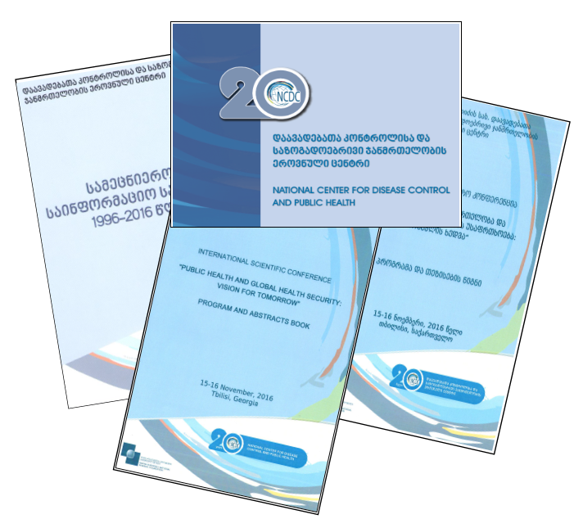
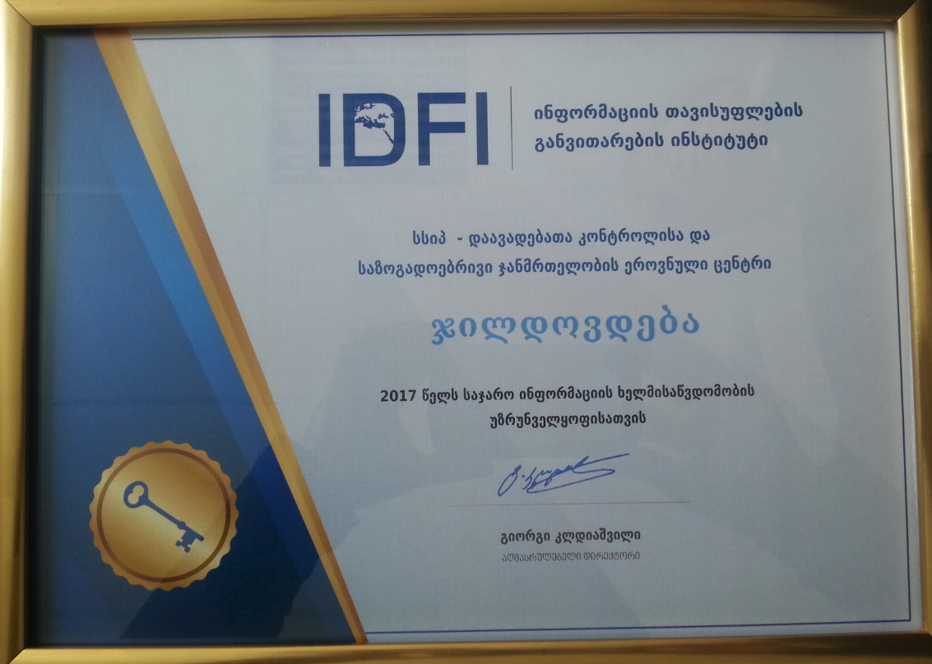
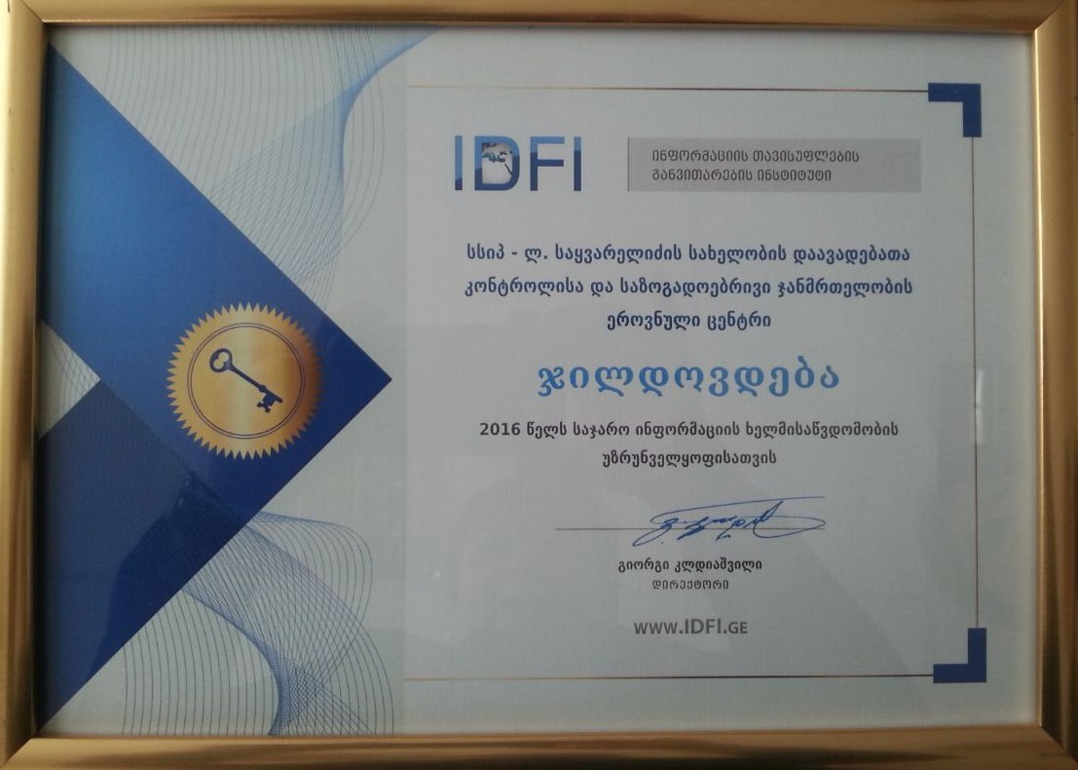
- Press conference dedicated to the World Antibiotic Awareness Week; Meeting on National Antimicrobial Resistance Surveillance Network; Visit of Assistant Secretary for Global Affairs of US Department of Health and Human Services Mr. Jimmy Kolker and Liaison Officer for Global Affairs office Ms. Karen Matthews to the Lugar Center of Public Health Research; 12th Yersinia International Symposium; NCDC 20 anniversary ceremony
- The Center permanently develops drafts of different legislative and normative acts
- The Center provides active communication campaigns with different communication channels (TV, radio, information agencies, press media, internet TV, internet portals and etc.)
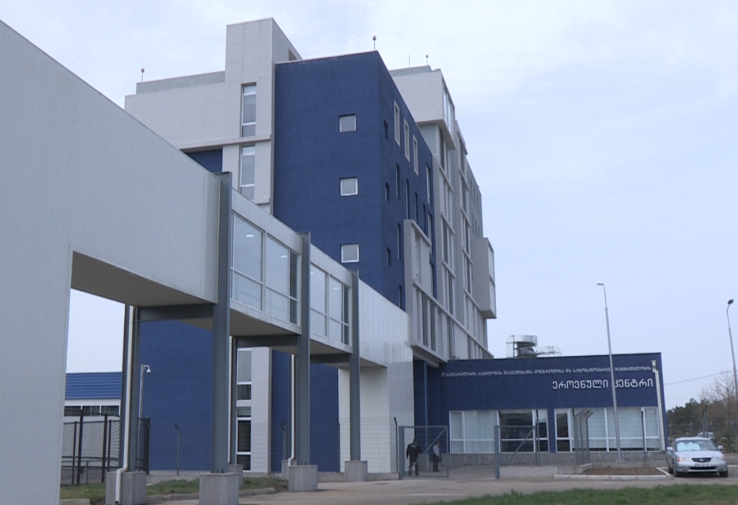
- According to the monitoring and research results of the Institute for Development of Freedom of Information (IDFI) NCDC has been nominated in succession twice as the most accountable and transparent organization of the year among public entities
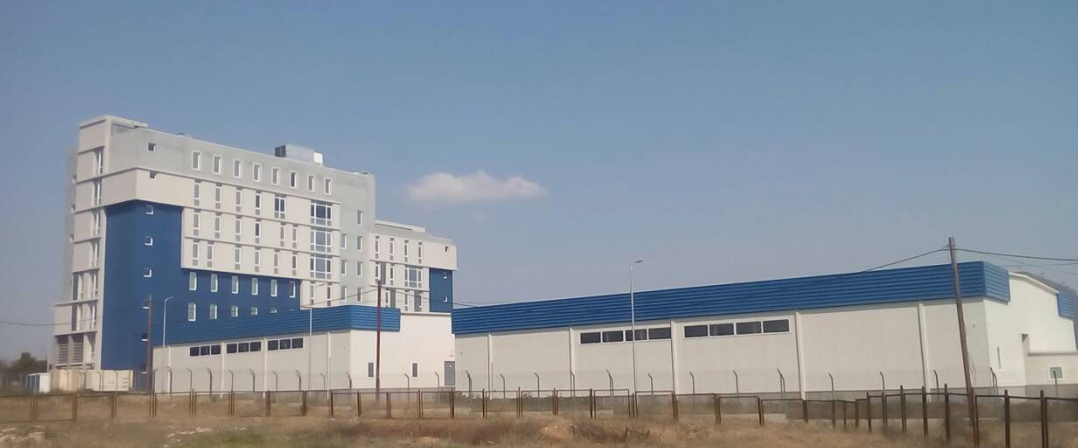
- The new administrative building of the Center was built with the financial support of the MOLHSA. The Lugar Center, referral laboratory, together with the warehouses will create a strong campus with the further development perspective

Financial Sustainability of NCDC

Due to increase of functionality of the NCDC the budget allocations from the Central Budget have been considerably grown.

NCDC Dynamics of Budgeting
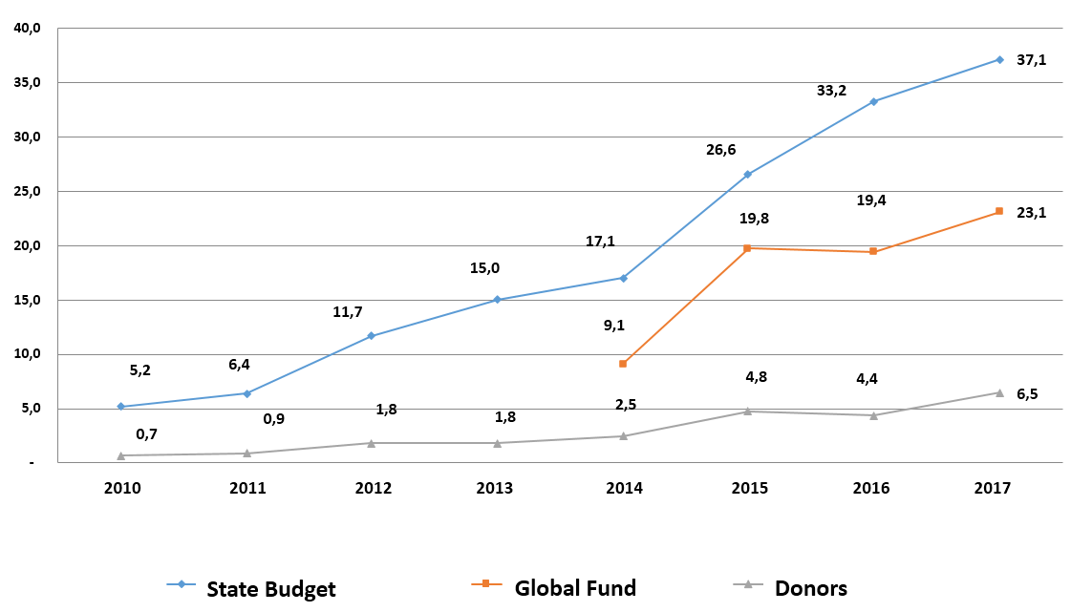

Dynamics of Weighted and Allocated Appropriations, Financed from the State Budget

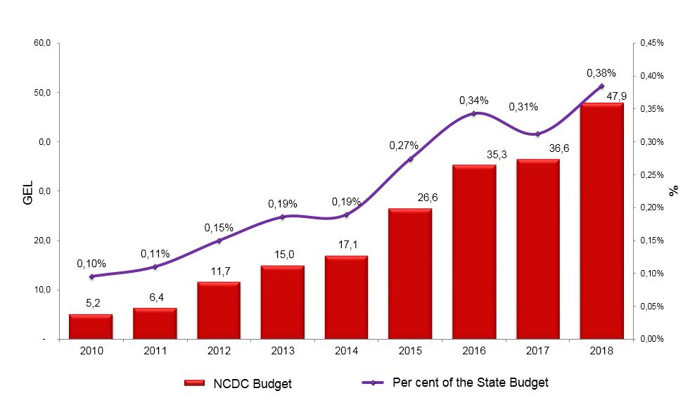

Dynamics of Spending Within the Donor Organizations Projects for 2012 - 2017 (Thousands GEL)

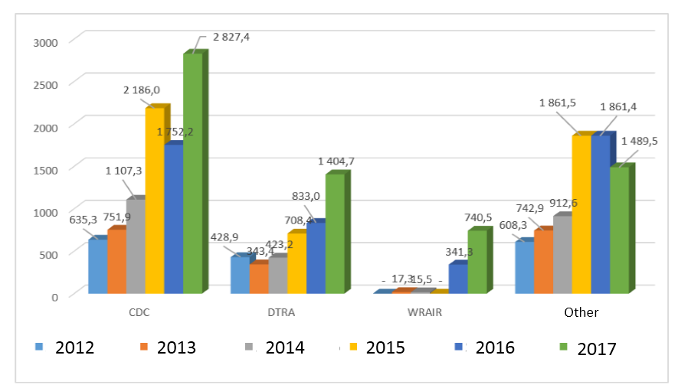
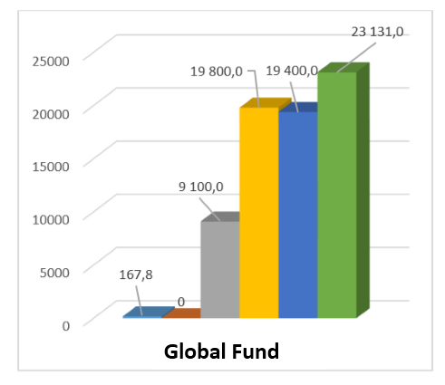
Commercial Activities

The major part of commercial revenue were presented by the incomes from commercial lab testing.
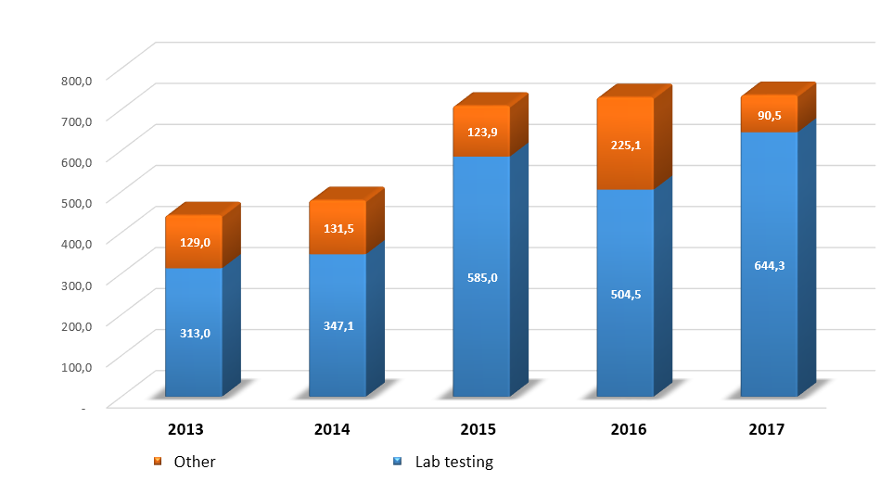
Key Challenges

- Increase of immunization advocacy and coverage in target groups
- Strengthening surveillance, monitoring and prevention of antimicrobial resistance and infection control and medical service associated infections
- Managing measles outbreaks
- Elimination of mother-to-child vertically transmitted infections
- Hepatitis C elimination cascade support within the competence
- High level of HIV infection-associated stigma among population
- Low detection rate of HIV infection, and high proportion of detections at a late stage
- Strengthening the supportive environment for enrollment of IDUs in “Needle and syringe program”
- Low level of the MDR and extensively resistant patients’ treatment
- Issue on providing continuous Tuberculosis services
- Strengthening of preparedness and response to public health risks; Multi-sectoral involvement in implementation of Global Health Security and International Health Regulations
- Expansion of the National External Quality Control Program and improvement of quality control
- Full operation of the Laboratory Information Management System (LIMS)
- Strengthening of laboratory capacities, intensify trainings and share experience for better exploitation of LSSs, in order to meet challenges related to diseases outbreaks management and good investigation performance
- Assessment of non-communicable disease surveillance for further improvement
- Strengthening tobacco control, promoting new legislative amendments
- Less priority of preventive medicine and public health
- Raising effectiveness of health promotion by implementation of continuous (non-fragmented) social media campaigns
- Creation of modern environment and health system and capacity building on NCDC basis
- More integration of public health programs into primary healthcare programs; creating a consistent system of public health for human resources training, continuous education and professional development
- Increasing cancer screening coverage for the target contingent; Raising public awareness and information level on the importance of screening
- Creating an unified system of blood production quality control; Upgrading the appropriate legislation;
- Reaching 100% coverage in newborn hearing primary screening for all newborns in Georgia
- Expanding of research directions; development of multidisciplinary research capabilities; introduction of new molecular, immunological, and viral research methods
- Development of thematic registries
- Complete digitalization of statistical reporting and improvement of data quality through implementation of various cross-sectional analyzes
- Deficiency / absence of updated training courses

